Jacqueline L. (Hoadley) Parks
January 14, 1965 – October 12, 2000
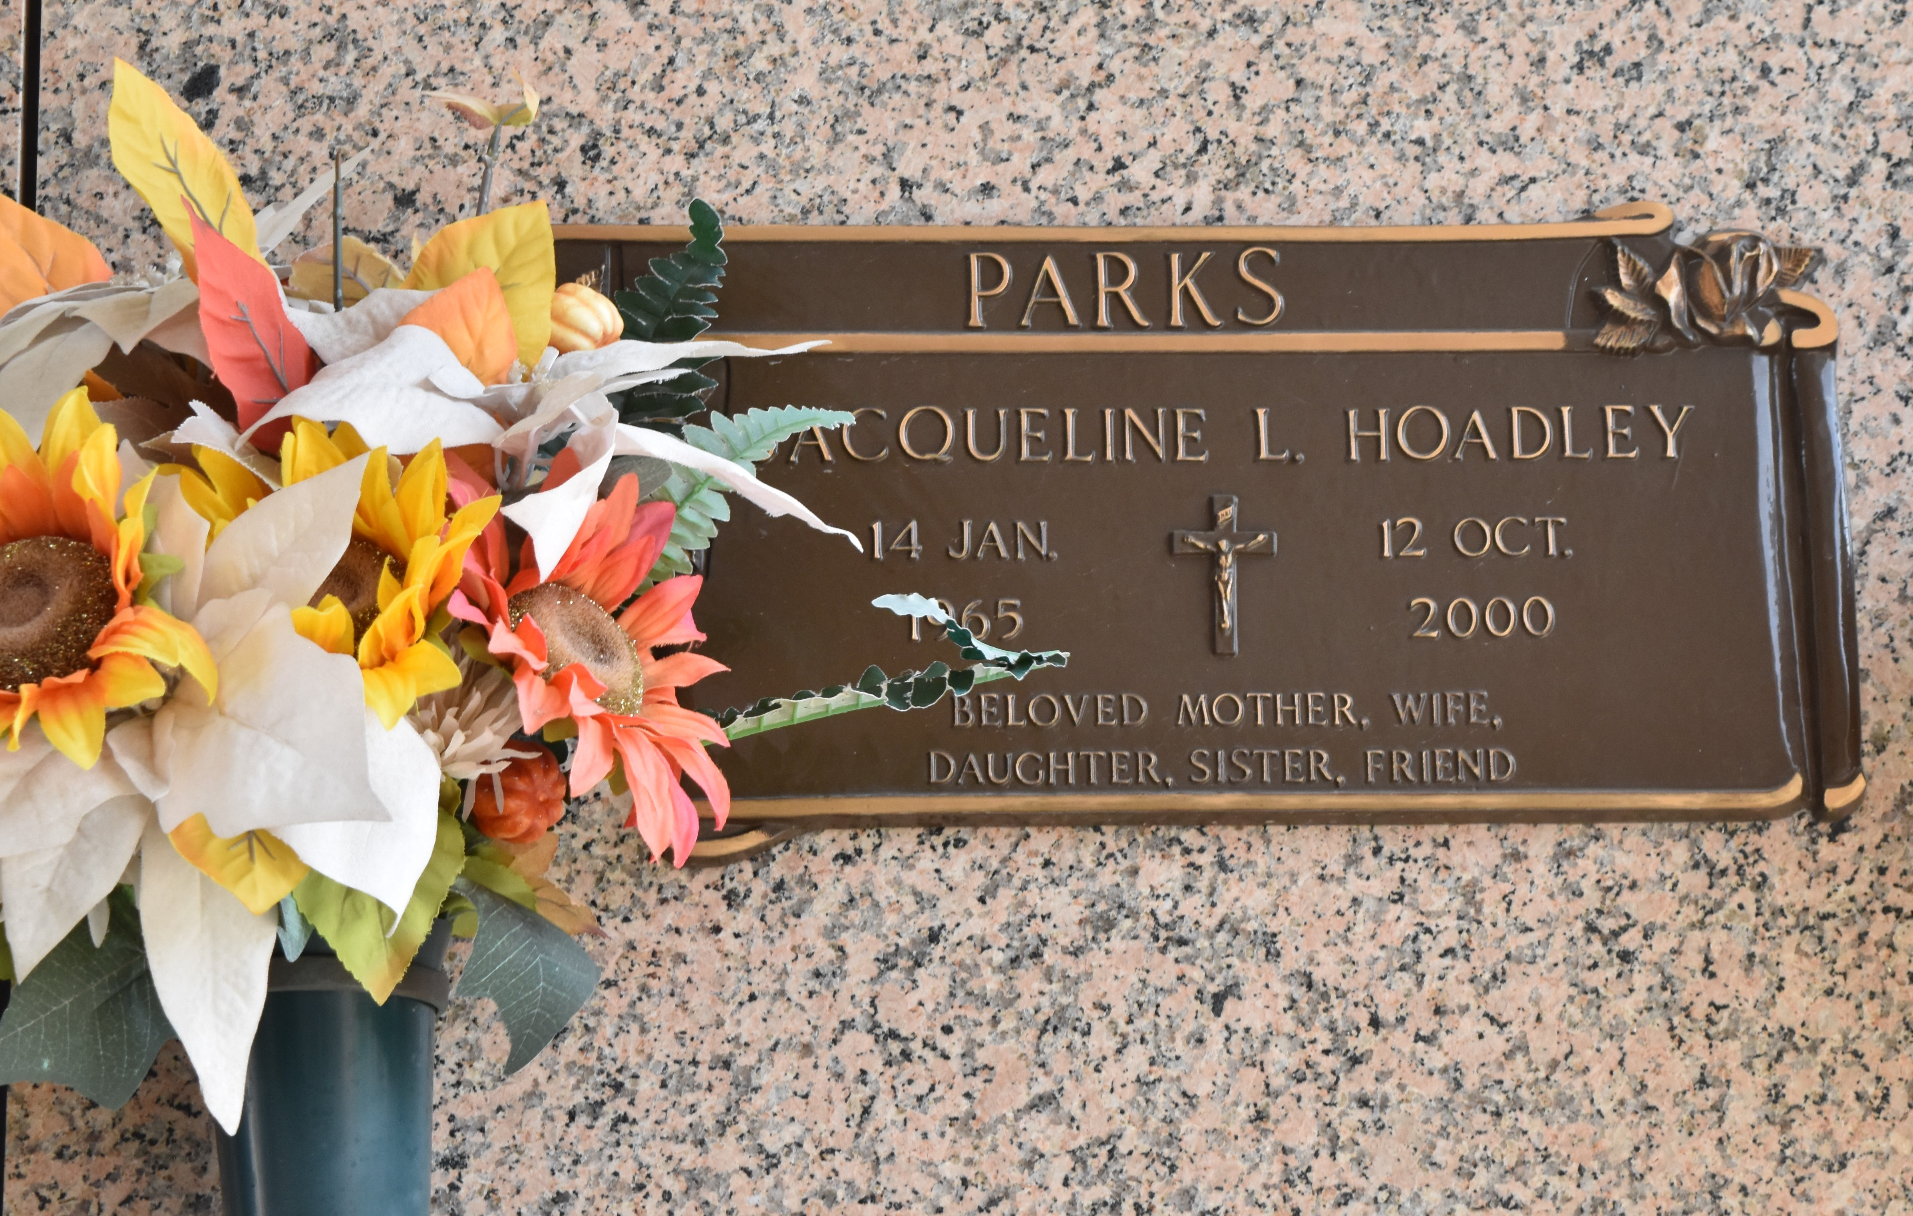

Mrs. Edna Lacorte Parks passed away on Saturday, June 11, 2016 at the age of 73. She is survived by her loving husband of 48 years, Wesley E. Parks, Sr.; children, Mischell A. Parks, Wendy F. Purcell and Wesley E. Parks, Jr.; grandchildren, Tayler, Morgan, Joseph "Joey" and Joshua. She was preceded in death by her daughter, Jacqueline "Jackie" Hoadley. Edna was a resident of LaPlace, LA since 1986. She was a long time employee of Lakeside Hospital and the Treasure Chest Casino.
The visitation will be held at Millet-Guidry Funeral Home, 2806 W. Airline Hwy, LaPlace on Friday, June 17, 2016 from 6:00 p.m. to 9:00 p.m. and at Ascension of Our Lord Church, 799 Fairway Dr., LaPlace on Saturday, June 18, 2016 from 11:00 a.m. to 1:00 p.m. followed by the Funeral Mass at 1:00 p.m. Interment in St. John Memorial Gardens Cemetery. To view or sign the online guest book, please visit www.milletguidry.com.

The New Orleans Advocate, Louisiana
Jun. 13 to Jun. 18, 2016

