Derron Micah Parquet
January 5, 1982 – November 23, 2017
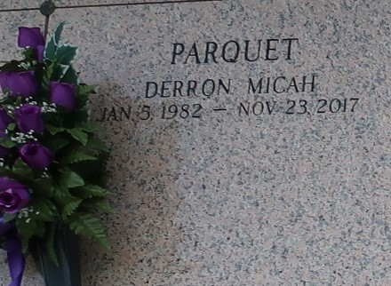

Derron Micah Parquet was born on January 5, 1982 and passed away on Thursday, November 23, 2017, at the age of 35. He was born in Metairie, La and was a resident of Metairie and Garyville, La. He is survived by his parents, Pamela Dickerson Parquet and Stanley P. Parquet, Jr. and his stepmother Marie Parquet; brother: Chris Parquet; Sisters: Shawn Parquet, Monique Watkins (Darrick), Monet Katko (Justine), Davanna Clofer Tripps, Demetra Cayold, Enadia Cayold, Jawanna Cayold, and Nikeya Breaux; Aunts: Verlina D. Simmons, Olivia D. Gordon, Gertie D. Polk (Louis), Irene D. Gordon-Jasmine (Calvin),Brenda D. Pierce, Lydia P. Molliere (Burnell), Marlene P. Brown (Clayde); Uncles: William Dickerson, Jr., Whitney Dickerson (Sandra), Floyd Dickerson, Kenneth Parquet (Karen), Michael Parquet (Ursula), Winslow Parquet, and Robert Joseph (Rosalyn); Godmother: Yvonne J. Joseph. Also survived by a host of nieces, nephews, and other relatives and friends.
He was preceded in death by his grandparents, William (Bill) and Edna Clark Dickerson and Stanley Parquet, Sr. and Leona Richard Parquet, a brother Kerrick M. Gordon, as well as uncles, Mose Simmons, Sr., Charles Gordon, Claude Gordon, Jr., and Godfather Linton Joseph.
The family would like to give special thanks to University Medical Center of New Orleans, Guardian Home Health, Garyville Fire Department, Acadian Ambulance Service, and St. John the Baptist Parish Sheriff's Office. Family and friends are invited to attend the Celebration of Life service on Saturday December 2, 2017 at 11:00 am at Bethlehem Baptist Church, 146 East 20th Street, Reserve, La. 70084. Visitation will begin at 9:00 am until service time. Pastor Carla Collins Ceasar of From My Heart to Yours Family Worship Center officiating. Interment will follow at St. John Memorial Gardens 2205 W. Airline Hwy. LaPlace, La. 70068. Bardell's Mortuary of Mt. Airy, La. in charge. Information: 985-535-6837.

The New Orleans Advocate, Louisiana
Nov. 30 to Dec. 2, 2017

