Edith Theresa Parquet
December 2, 1936 – December 25, 2013
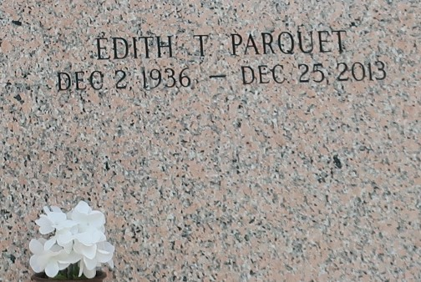

EDITH THERESA PARQUET "EDIE" on Wednesday, December 25, 2013 at her home in LaPlace, LA. Daughter of the late Olevia Robinson and Charles Parquet. Mother of Andrea Parquet-Taylor (Todd) and David Parquet. Sister of Shirley Doley, Leah Williams, Ernest, Clyde and Melvin Parquet, the late Catherine Deterville, Thomas, Stanley, Randall, Leonard and Nicholas Parquet. Also survived by 2 grandchildren and a host of nieces, nephews, cousins, other relatives and friends. Age 77 years. A native and resident of LaPlace, LA.
Relatives and friends of the family, also priest and parishioners of Our Lady of Grace Catholic Church and all neighboring churches are invited to attend the Funeral Mass at Our Lady of Grace Catholic Church, 772 Highway 44, Reserve, LA on Friday, January 3, 2013 at 10:00 AM. Father Christopher Amadi, Celebrant. Interment St John Memorial Garden Cemetery, LaPlace, LA. Visitation at the above named church from 8:00 AM until Mass time. SERVICED BY ROBOTTOM

The Times-Picayune, New Orleans, Louisiana
Dec. 31, 2013 to Jan. 1, 2014

