Eric Wayne Parquet
November 26, 1957 – June 5, 2007
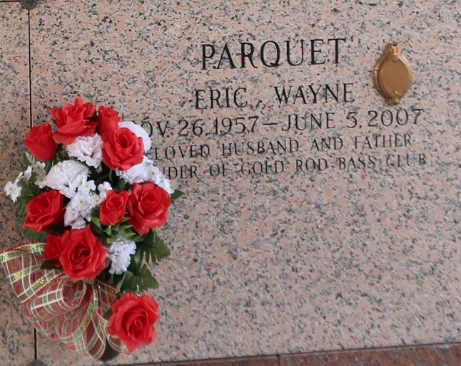

Eric Wayne Parquet, at Southaven Baptist Memorial Hospital, Southaven, MS, on Tuesday, June 5, 2007. Son of Ernest Parquet, Sr. and Olivia Burl Parquet. Beloved husband of Kim Mason Parquet. Father of Kaylio Parquet. Brother of Ernest Parquet, Jr., Rodney Parquet, Derek Parquet, Jacqueline Mitchell of LaPlace, LA and Lynn Millet of Lithonia, GA. Also survived by a host of nieces, nephews, aunts, uncles, cousins, other relatives and friends. A native of LaPlace, LA and a resident of Southaven, MS. Age 49. Mr. Parquet was an industrial operator, died of cancer.
Relatives and friends of the family; also pastors, officers and members of the First Community Antioch B.C. and neighboring churches; Leon Godchaux High School Class of '75 and Gold Rod Bass Club are invited to attend the Funeral Services on Monday, June 11, 2007 at 11:00 a.m. from the First Community Antioch B.C., 10860 Hwy. 3125, Lutcher, LA. Rev. F. Gaines, officiating. Visitation at the Church after 9:00 a.m. Entombment St. John Memorial Gardens, 2205 W. Airline, LaPlace, LA. THE BALONEY FUNERAL HOME, L.L.C. 399 Earl Baloney Dr., Garyville, LA 70051 Information: (985) 535-2540 IN CHARGE OF ARRANGEMENTS

The Times-Picayune, New Orleans, Louisiana
Jun. 10, 2007

