Olivia Burl Parquet
March 2, 1936 – August 29, 2007
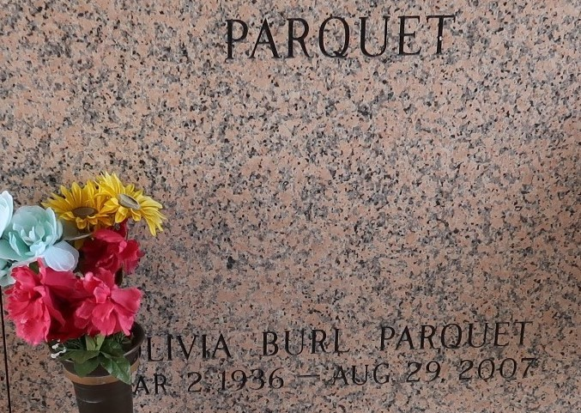

Olivia "Ollie Bee'' Burl Parquet, on August 29, 2007. Daughter of the late Elvin and Albertine Nelson Burl. Wife of Ernest Parquet, Sr. Mother of Ernest Parquet, Jr., Jacqueline Parquet Mitchell, Lynn Parquet Millet, Rodney Parquet, Derek Parquet and the late Eric Parquet. Special motherly relationship with Kenric Nickelson. Mother-in-law of Kim Mason Parquet, Bridget Dorsey Parquet, Whitney Mitchell, Perry Millet and Schewone Sorapuru Parquet. Grandmother of Torrey Parquet, Andre Millet, Anya Millet, Kernell Jupiter, Keya Parquet, Kia Walker, Ariel Jupiter, Keri Parquet, Kayliv Parquet, Bria Mitchell, Tia Mitchell and Nyla Williams. Godmother of Sandra Bell. Sister of Mary Burl Bell, Gloria Burl Davis, Laureen Burl Arceneaux, the late Beryl Burl Joseph, Wilbert Burl, Alvin Burl. A graduate of Fifth Ward High School in 1956, member and usher of First Community Antioch Baptist Church. A native of Mt. Airy, LA and a resident of LaPlace, LA for 49 years.
Relatives, friends and employees of DuPont, Valero, Wendy's and Hanover and Pastors, officers and members of First Community Antioch Baptist Church are invited to attend the Funeral Services on Saturday, September 1, 2007 at 10:00 AM at First Community Antioch Baptist Church, 10860 Highway 3125, Lutcher, LA. Rev. Ferdinand Gaines, Jr., officiating. Visitation at the Church at 8:00 AM. Entombment at St. John Memorial Gardens, 2205 W. Airline Highway, LaPlace, LA. Arrangements by Hobson Brown Funeral Home.

The Times-Picayune, New Orleans, Louisiana
August 31, 2007

