Rodney M. Parquet
July 2, 1964 – March 6, 2011

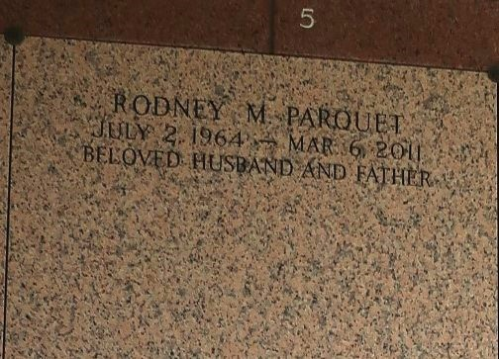

Rodney Parquet, age 46, a District Manager for Wendy's Hamburger for 28 years died on Sunday, March 6, 2011. He leaves behind his wife Michelle Parquet; two daughters: Tori Walker, and Nyla Williams; one son, Nicholas Williams; his father, Ernest Parquet, Sr.; 2 brothers, 2 sisters, and a host of nieces, nephews, aunts, uncles and cousins.
Services will be on Saturday, March 19, 2011 at First Community Antioch, 1086 Hwy. 3125, Lutcher, La., at 11:00 a.m. Rev. Ferdinand Gains, Pastor - Officiating. Visitation at the Church from 9:00 a.m. until service time. Interment in St. John Memorial Cemetery, LaPlace, La. Professional Service Entrusted to Hobson Brown Funeral Home Garyville, La 70051 (985) 535-2516

The Times-Picayune, New Orleans, Louisiana
Mar. 18, 2011

