Patricia (Smith) Parrilla
September 15, 1950 – September 26, 2019

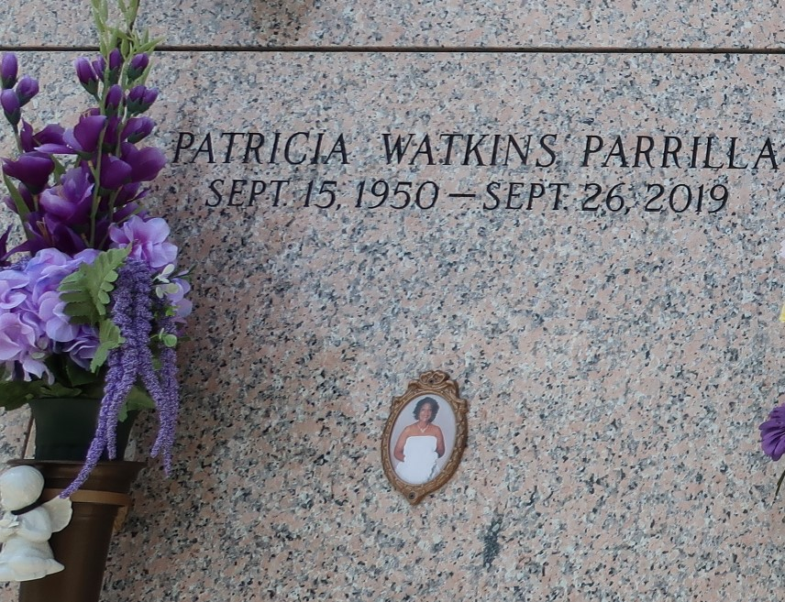

Patricia, affectionately known as “Teeda”, by her family and friends, was the daughter of Roger and Leona Smith. Patricia accepted Christ at the tender age of 7 years old and was baptized by the late Rev. Forest Green and the late Rev. Junius Cureaux at New Hopeful Baptist Church, Garyville, LA. She joined Beech Grove Baptist Church in 1980 under the leadership of Rev. Wesley Anderson, Sr.
Patricia was united in holy matrimony in December 1971 to the late John Watkins, Jr. To this union, six children were born: Randell, Denise, Takisha, Cornel, Deondra and Kyron Watkins and in May 2006 she was united in holy matrimony to Rafael Parrilla.
Patricia was educated in the St. John the Baptist Parish School System. Patricia loved working for the church at Beech Grove. She was joyfully involved in the Senior Choir, Choir Officer, Pastor’s Aid, Sunday School, Vacation Bible School, Church Anniversary Committee and Graduates Baccalaureate Program and any other activities of the church. She attended church and worked faithfully until her health prevented her from doing so. Patricia love for gospel music was a highlight of her life as she enjoyed Quartet singing and she would travel in order to see her favorite groups.
Patricia leaves to cherish her precious memories, her devoted husband Rafael Parrilla, her loving children: Randell (Sharell) Watkins, Denise (Willie, Jr.) Marshall, Takisha (Kimberly) Watkins, Cornel (Karen) Watkins, Deondra (Dentrell) Moody and Kyron Watkins, 27 grandchildren, 17 great-grandchildren, step-children, siblings, Walter (Glory) Scott, George (Marie) Scott, Brenda (Stanley) Eugene, and a host of nieces, nephews, relatives, friends, and 4 godchildren.
Patricia was preceded in death by her parents Roger and Leona Smith, her siblings, Herman and Raymond Scott, Verlina Davis, Roger Smith, Jr., Ivery Smith, Audrey Breaux and Lillie Mae Fobh.
Relatives, friends of the family, and all neighboring churches are invited to attend the funeral service at Greater New Mt. Zion Baptist Church, 105 Historic East, Garyville, La 70051 on Saturday, October 5, 2019 at 11:00 a.m. Visitation will begin at 9:00 a.m. Entombment St. John Memorial Gardens. There will be a viewing and musical held on Friday, October 4, 2019 at Greater New Mt. Zion Baptist Church, 105 Historic East, Garyville, La 70051 at 6:00pm. Final care has been entrusted to Treasures of Life Funeral Services, 315 E. Airline Hwy Gramercy, LA 70052.

Treasure of Life Funeral Services, Gramercy, Louisiana

