Freddie Pate Sr.
July 3, 1930 – February 15, 2019
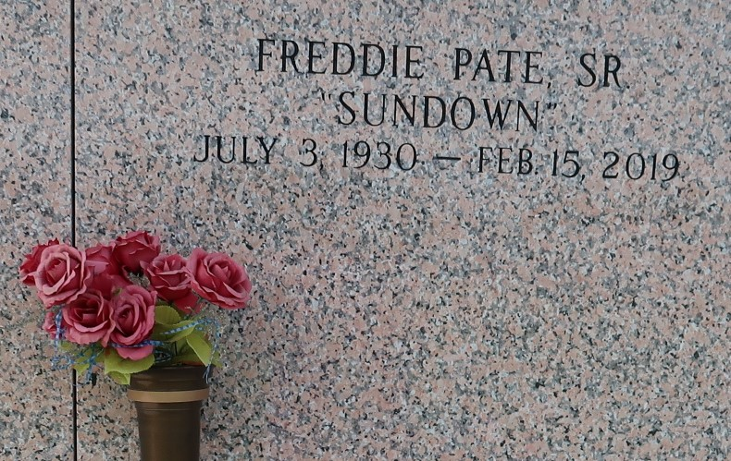

Freddie Pate, Sr. "Sundown" on Friday, February 15, 2019 at Ormond Nursing and Care Center, Destrehan, LA. Son of the late Maehanna "Nabae" and Eddie Pate. Father of Gail Mazique (Curtis), Freddie Pate, Jr. (Linda), Dale P. Thomas (Peter), Ronald Pate (Debra), Angelique Pate, Eddie Pate (LaShonda) and the late Rebecca Baker. Stepfather of Cheryl Thomas. Brother of James Gibson, Sr., Gloria Russell, Audrey Morris, the late Emily P. Boykins, Edna P. Brown, Annie Young Eldridge and Dorothy P. Perrilloux. Also survived by 12 grandchildren, 21 great grandchildren, 2 great great grandchildren and a host of nieces, nephews, cousins, other relatives and friends. Age 88 years. A native of Garyville, LA and a resident of LaPlace, LA.
Relatives and friends of the family, also pastors, officers and members Riverlands Christian Center and all neighboring churches are invited to attend the Funeral Service at Riverlands Christian Center, 123 Redemption Way, Reserve, LA on Friday, February 22, 2019 at 10:00 AM. Rev. Steven Perrilloux, Sr., Pastor, Officiating. Interment St John Memorial Garden Cemetery, LaPlace, LA. Visitation at the above named church from 8:00 AM until Service Time SERVICED BY ROBOTTOM

The Times-Picayune, New Orleans, Louisiana
Feb. 20, 2019

