Ben Frederick Pelot III
August 14, 1945 – January 10, 2004
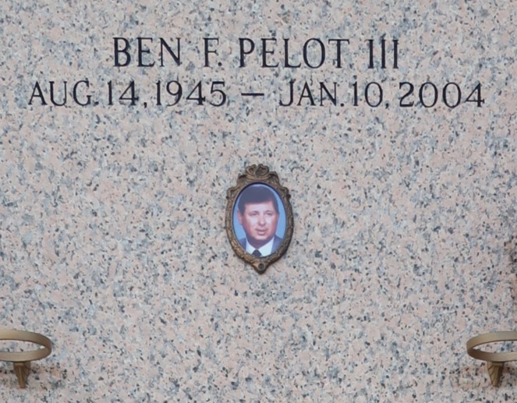

Ben Frederick Pelot, III on Saturday, January 10, 2004. Beloved husband of Linda Gallo Pelot. Father of Ben F. Pelot, IV, JoLynn Ball, Branden M. Pelot, Alicia P. Anderson and Brett F. Pelot. Son of Rose Mary W. Bijak and the late Ben F. Pelot, II. Stepson of Julian Bijak. Brother of Elizabeth Hebert, Barbara Felps, Marie Shaub and John Murray. Grandfather of Ben F., V, Ryan M. and Dillon M. Pelot, Kayla M. Bosch, Mason J. Hernandez, Baylin O. Cooney and Joshua A. Anderson. Aged 58 years, a native of New Orleans and a resident of St. Rose for the past 20 years.
Relatives and friends of the family are invited to attend the funeral. Services from the Kenner Funeral Home of L. A. Muhleisen & Son, 2607 Williams Blvd on Tuesday, January 13, 2004 at 11:00 o'clock a.m. Interment in St. John Memorial Gardens Cemetery. Friends may visit from 6:00 p.m. until 9:00 p.m. on Monday and after 9:00 a.m. on Tuesday.

The Times-Picayune, New Orleans, Louisiana
Jan. 11 to Jan. 12, 2004

