Annie (Valenti) Perilloux

August 19, 1930 – February 9, 2009

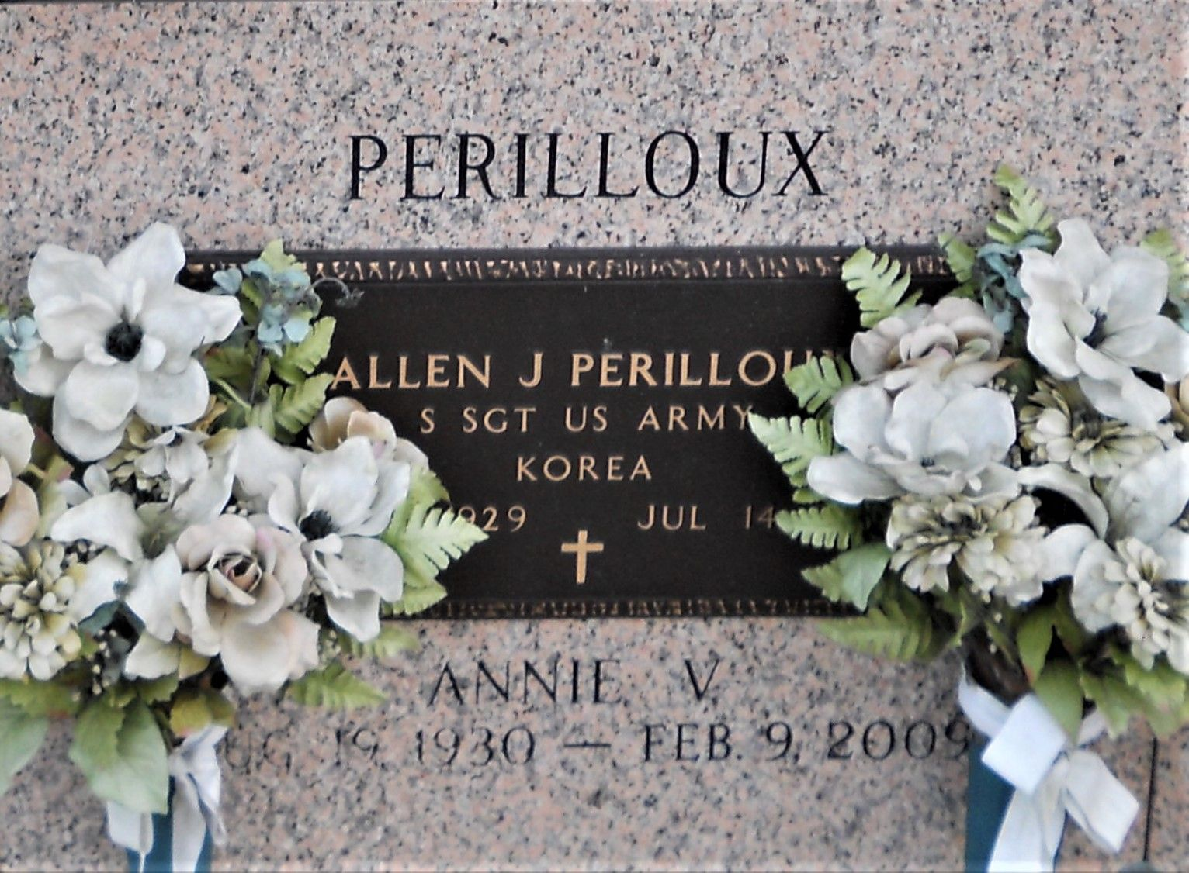

Photo by Team T Lo

Annie Valenti Perilloux on Mon. Feb. 9, 2009 at 3:53 p.m. Beloved wife of the late Allen Perilloux. Mother of Julie P. Montz & husband Terry E., Janet P. Sistrunk & husband Keith and Bret Perilloux & wife JoAnn. Also survived by 6 grandchildren and 1 great-grandchild. Daughter of the late Frank & Mary Valenti. Sister of Belle Tourres, Pete Valenti and the late Cecila Monistere. Age 78. A native of Hammond, La. and a resident of LaPlace, La. for the past 50 yrs.  
  
Relatives and friends are invited to attend services. Visitation at Millet-Guidry Funeral Home, 2806 W. Airline Hwy., LaPlace, La., on Wed. Feb. 11, 2009 from 5:00 pm. to 10:00 p.m. and on Thur. from 8:00 a.m. to 10:00 a.m. Followed by religious services at the funeral home chapel at 10:00 a.m. Burial in St. John Memorial Gardens Cemetery, LaPlace.

Times-Picayune, The (New Orleans, LA) - Wednesday, February 11, 2009

Contributed by Jane Edson