Inez (Madere) Perilloux
March 5, 1923 – November 21, 2001
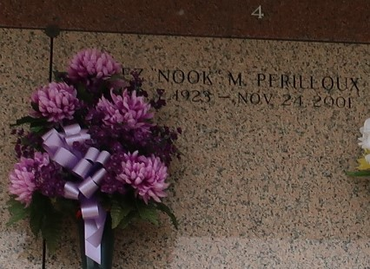

Inez (Nook) Madere Perilloux, on Saturday, Nov 24, 2001 at 5:48PM. Beloved wife of Joseph Perilloux Jr. Mother of Ellis, Arlen and Timmy Perilloux. Mother-in-law of Lois and Linda Perilloux and the late Jeanne Perilloux. Also survived by 5 grandchildren and 7 great grandchildren. Age 78 years. A resident of Laplace.

Relatives and friends of the family are invited to attend the Funeral services at Millet Guidry Funeral Home, Laplace, on Tuesday Nov 27 2001. Followed by Religious Services in the Funeral Home Chapel at 10 am. Burial in St John Memorial Gardens, Laplace. Visitation from 5 pm to 10 pm on Monday and from 8 am until services on Tuesday.

The Times-Picayune, New Orleans, Louisiana
Nov. 25, 2001

