Joseph Sydney Perilloux Jr.
July 5, 1921 – January 17, 2023
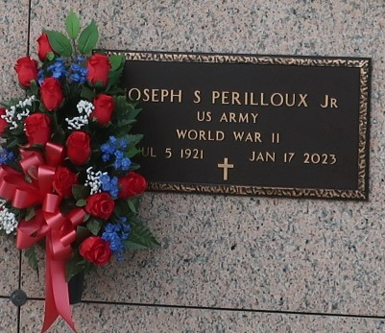
Joseph "Joe" Sydney Perilloux, Jr. passed away on Tuesday, January 17, 2023 at the age of 101. He was a native and resident of Montz, LA. He was an Army Veteran for nearly two years and served in World War II. He spent his career years at GATX, working at a car repair shop in Good Hope and then working construction in Norco. His work ethic and devotion to his family have always been strong and his lessons taught will live on through his family forever.
His surviving loved ones include his son, Timmy J. Perilloux and grandchildren, Lisa Forsythe (Yancy), Darlene Blake (the late Jamie), Dana Fletcher (Steven), Rebecca Perilloux and Spencer Perilloux (Kira). He is also survived by 11 great grandchildren and 6 great-great grandchildren.
He is the beloved husband of the late Inez "Nook" Madere Perilloux and loving father of the late Ellis J. Perilloux (the late Lois) and the late Arlen J. Perilloux (the late Jeanne); son of the late Clothilde Millet Perilloux and Joseph Perilloux, Sr. Brother of the late Myrtle, Arthur, May, Rita, Gladys and Elliot.
Relatives and friends are invited to attend a Visitation on Saturday, January 21, 2023 from 8:30 AM-10:00 AM at Millet-Guidry Funeral Home, 2806 W. Airline Hwy., LaPlace, LA. Words of Remembrances in the parlor will begin at 10:00 AM. A Graveside Service will be at 10:30 AM at St. John Memorial Gardens Cemetery, LaPlace, LA.

Published on Legacy.com by Millet-Guidry Funeral Home
Jan. 19, 2023

