Raymond J. Perilloux
December 29, 1927 – February 13, 2009
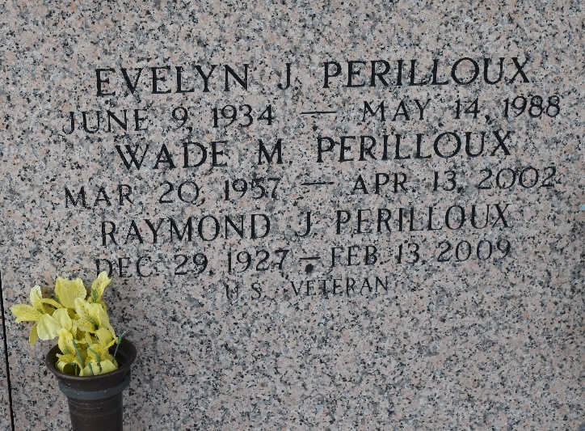

Raymond J. Perilloux on Friday, February 13, 2009 at 4:10am. Beloved husband of Tena Guzzardo Perilloux and by first marriage of the late Evelyn Johnson Perilloux. Father of Ivy Phillips and husband Bruce of Kenner, David Perilloux and wife Bambi of LaPlace, Cynthia Blouin of LaPlace, Lisa Perilloux and companion Markus Wittmann of New Orleans and the late Wade Perilloux. Grandfather of Chase Blouin, Derek, Josh and Sarah Perilloux, Brian Phillips, Dylan Louque and the late Brant Phillips. Great-grandfather of Preston Kiefer and Averie Perilloux. Son of the late Lucien and Albertine Perilloux. Brother of Anna Mae Schutz, Leonard, Ronald and Brent Perilloux, Delores Millet and the late Calvin Perilloux. Age 81 years. A native of LaPlace and a resident of Amite.
Relatives and friends are invited to attend services. Visitation at Millet-Guidry Funeral Home, 2806 W. Airline Hwy, LaPlace, La. on Monday, February 16, 2009 from 9:00am to 11:45am. Followed by Religious Services at St. Joan of Arc Catholic Church, LaPlace at 12:00 noon. Burial in St. John Memorial Gardens Cemetery, LaPlace. In lieu of flowers, masses or donations to the American Heart Association or American Cancer Society.

The Times-Picayune, New Orleans, Louisiana
Feb. 15, 2009

