Ronald Neil Perilloux
November 14, 1930 – February 24, 2011
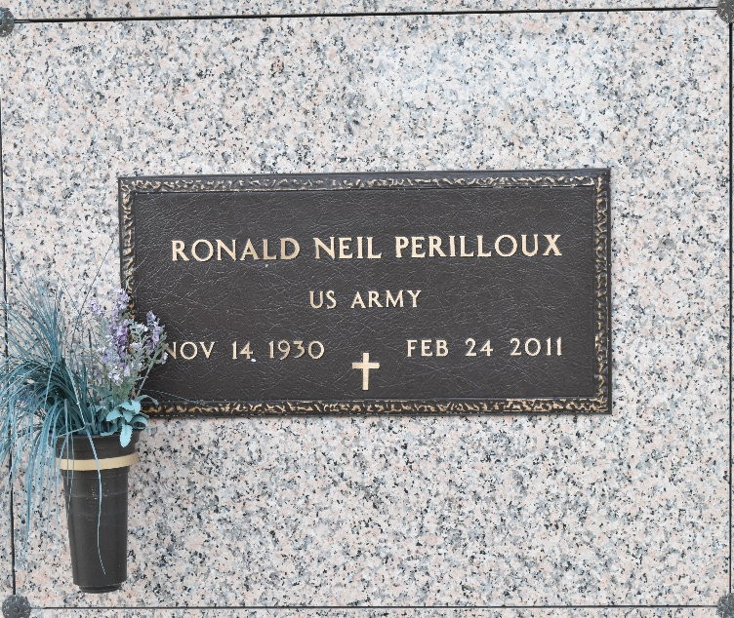

Ronald Perilloux passed away peacefully on Thursday, February 24th, 2011 after a short, yet brave battle with cancer. Ronald was born in LaPlace, Louisiana on November 14th, 1930 to Lucien and Albertine Perilloux. Ronald is survived by his wife, Carmen Klibert Perilloux; children: Barry "Iron Man" and his wife Beverly, Christie Molinet and her husband King, Ronnie, Todd "Tape" and his wife Santhi, Chad "Lout", and Gina Mullins and her husband Steve; 13 grandchildren, 5 great-grandchildren; also brothers: James Brent and Leonard Perilloux; and sisters: Anna Mae "Mamie" Schutz and Delores Millet. He was preceded in death by his parents: Lucien and Albertine and his brothers: Calvin and Raymond.
Ronald was an all-star football player at Leon Godchaux and attended LSU. He started his career at Shell Oil Company in Norco, LA and retired in 1985 after 33 years of service. Ronald enjoyed hanging out at his camp at Pleasure Bend on Lake Des Allemands. He grew an award worthy garden year round. He loved making Andouille that would later be used in his famous gumbo at family gatherings.
Friends will be received Monday, February 28, from 9:00 am till 11:00 am at Ascension of Our Lord Church in LaPlace, LA. A Mass of Christian Burial will follow interment will follow in St. John Memorial Gardens in LaPlace, LA. In lieu of flowers, masses preferred or contributions through AOL for Father Benny Piovan's work in Saltillo, Mexico Arrangements by Millet-Guidry Funeral Home, LaPlace, LA.
The Times-Picayune, New Orleans, Louisiana
Feb. 27, 2011

