Era Myra (Ard) Perrilloux
May 18, 1957 – August 8, 2022
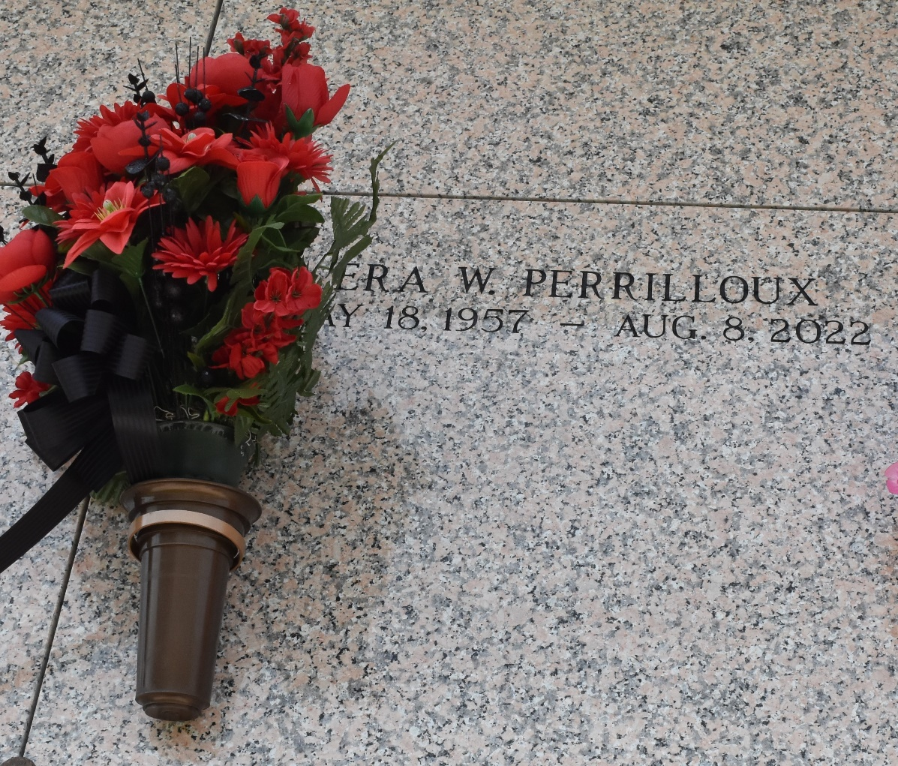
Era Myra Perrilloux, affectionately known as Tiny, transitioned from her earthly home on Monday, August 8,2022, surrounded by her loved ones at the age of 65. Era was born on May 18, 1957 to Mary D. Ross and the late Hollis Ard, Jr.
Era was a graduate of Scotlandville High School and enjoyed working. She was a long-time employee of the fast-food industry and a security supervisor for Acts, formerly Gate Safe. Era was a member and served as an usher at Faith of Hope Baptist Church. Era was a very loving person, who never met a stranger. She opened her heart and home to anyone who needed it, including pets. We all know she loved to play her lottery and most importantly, we know she loved her family, friends and God.
Era was the wife of Ferdinand E. Perrilloux, Jr. and the daughter-in-law of Ethel Mae Perrilloux was the mother of David Williams, Eric (Rolanda) Perrilloux, Shelitha Brown, Ferdinand (Vinita) Perrilloux, III, Erica Perrilloux, and Stepmother of Aaron Stewart. She was the sister of Loletha (Darrell) Davis, Reallus Lee, Latorrie (Marlon) Cooper, Audrey Fay Self, Pamela Harrell, Yvonne Ard, Shelton Harrell, and Alfred (Linda) Ard. She was the Godmother of Traneissa Bolden, Kaina Gauff, Jennifer Thompson and Iniya Vanzant. She was the grandmother of Dyraneka, Christian, La Darren, Erianda, Tatyana, Davin, London, Tiana, Paris, Tania, and Germany, and the great grandmother of Mason and Madison.
She was preceded in death by her grandparents, Ernest and Teller B. Williams, father, Hollis Ard, Jr., brothers, Keith Ard and Holllis Ard, III, grandchildren, Marlon Williams and Kartasha Perrilloux, brothers-in-law, Freddie Perrilloux and Edward Stagg, and stepson Jeremiah Randle.
Era leaves to cherish her memories, her mother, husband, mother-in-law, children, grandchildren, sisters, brothers, nieces, nephews, aunts, uncles and host of other relatives and friends. Era will truly be missed by all who have come to know and love her!
Relatives and friends of the family, Pastors, Officers of Milesville Church of God in Christ, Faith of Hope Baptist Church and all neighboring churches are invited to the Celebration of Life, Saturday, August 20, 2022 at 10:00 am, 129 Apple Street, LaPlace, LA 70068. In accordance with the CDC guidelines for COVID-19 mask are suggested for all in attendance. Visitation at the above-named church 9:00 am until time of service. Interment St. John Memorial Gardens, 2205 W. Airline Hwy, Laplace, LA 70068.

Published on Legacy.com by Patrick H. Sanders Funeral Home, LaPlace, LA Aug. 19, 2022

