John Richard Perrilloux
1933 – July 24, 2015

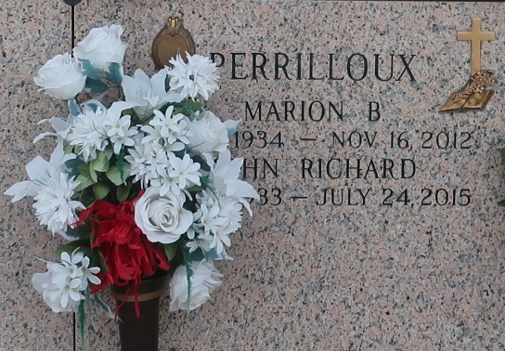

John Richard Perrilloux entered into eternal rest on Friday, July 24, 2015. He is the beloved husband of the late Marion B. Perrilloux, the father of (8) children, survived by (17) grandchildren, (22) great grandchildren, other relatives and friends. Age 81.
Funeral service will be held at Mt. Calvary Baptist Church, 127 West 3rd St., Laplace, La on Saturday, August 1, 2015 at 11:00am. Visitation at 9:00 am until service time. Rev. Freddie Howard, Pastor officiating. Internment St. John Memorial Garden, Laplace, LA. Service Entrusted to Hobson Brown Funeral Home Garyville, La 70051 985-535-2516
The Times-Picayune, New Orleans, Louisiana
Jul. 29 to Jul. 31, 2015

