Michael Jamal Perrilloux
April 7, 1999 - January 7, 2022

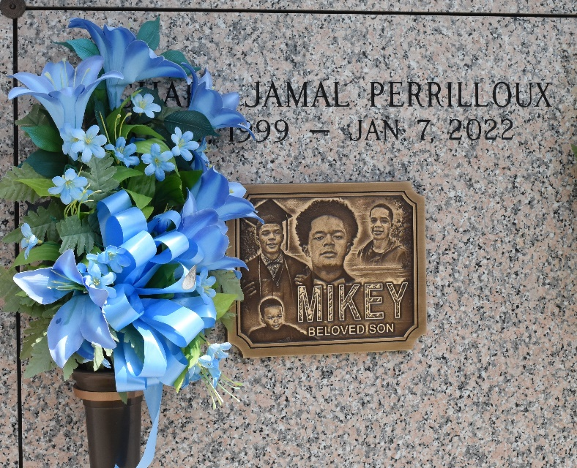

On January 7, 2022, God dispatched his angels to carry his child home to be at peace at the age of 22. Michael "Mikey" Perrilloux was born on April 7, 1999, at Lakeside Hospital, to the late Tawashi Hutchinson-Hamilton and Melvin Perrilloux, Jr. Mikey resided in St. John the Baptist Parish. He was a 2017 graduate of East St. John High School. He attended Grambling State University. Mikey enjoyed football, screen printing, and hanging with his brothers, cousins, and friends. He loved dogs especially, Coco and Louie. He formerly worked at McDonald’s and Enterprise Rent-A-Car. Mikey was an entrepreneur and was very optimistic in life.
Mikey leaves to cherish his memories with his father, Melvin Perrilloux, Jr. (Brandie); step-father, Lance Hamilton, Sr.; loving grandparents, Gwendolyn Christy, Cheryl Perrilloux, Miranda Perrilloux, and Curtis Brumfield; daughter, Kyleigh Joelle, siblings: Alondria, Darius, Blakele', Jalayia, Mikayla, Landon, and Lance, Jr.; Godsisters, Ty Booth and Tanisha "Tweedy" Hutchinson; aunts, Tatanisha White (Godmother), Dayna Mitchell (Blaine), and Samantha Thomas; uncle, Nakia (Godfather), Godparents, Quieshonna Booth and Ormonde Modica; dear friend, Bryante Antoine, and a host of great aunts, great uncles, cousins, and friends.
He is reunited in heaven with his mother Tawashi Hutchinson-Hamilton; grandfather, Melvin "Bud" Perrilloux, Sr.; great-grandfathers, Joseph Perrilloux, Nathan Bright, and Matthew Banks, Sr.; great-grandmothers, Marie Brumfield, Ella Mae Perrilloux, and Harriet Banks; aunt, Gaynelle Perrilloux-Ellis, and uncle, Steven Brown.
Family and friends are invited to attend a Celebration of Life Service on Saturday, January 22, 2022, at Riverlands Christian Center, 123 Redemption Way, Reserve, LA, 70084 at 11am. Visitation from 9am-11am. Entombment will follow at St. John Memorial Gardens, 2205 W Airline Hwy., Laplace, LA 70068. 70052.

Treasures of Life Center, Gramercy, LA
February 25, 2022

