Charles Howard Persinger
October 4, 1976 - February 14, 2020
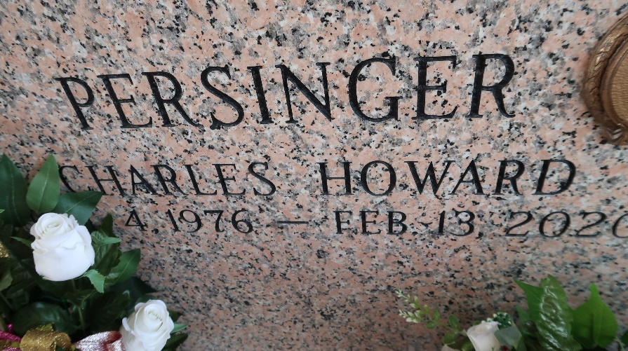

On Thursday, February 13, 2020, Charles Persinger, beloved son, brother, and uncle, passed away at the age of 43. Charles was born on October 4, 1976 in Metairie, LA to Del and Kathy Persinger. Charles graduated from East St. John High School in Reserve, LA and then earned his Associate's Degree in Safety from Delgado University in New Orleans, LA. He worked for the Army Corps of Engineers and then as a process operator in the petrochemical industry. Charles was a very kind and loving person and will be missed by all who knew him.
Charles is survived by his parents, Del and Kathy Persinger; his brother and sister-in-law, Del Jr. and Jin Persinger; two nephews, Elijah and Del III Persinger; fiancée, Callie Crouch; many aunts, uncles, cousins and friends.
The Persinger family would like to recognize two of his lifelong friends who stood by him, Tony Avocato and Dennis Castillo.
Relatives and friends are invited to attend the Funeral Service at Millet-Guidry Funeral Home, 2806 W. Airline Hwy., LaPlace on Saturday, February 22, 2020 at 2:00 p.m. Visitation will be held from 12:00 p.m. until 2:00 p.m. Interment in St. John Memorial Gardens Cemetery.
Millet-Guidry Funeral Home, LaPlace, Louisiana
February 18, 2020

