Anthony J. Pisciotti Jr.
January 8, 1944 – July 21, 2021
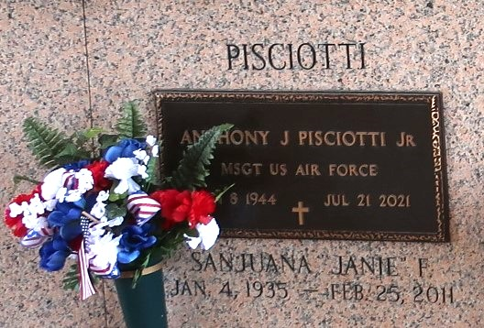

Msgt. Anthony J. Pisciotti Jr. passed away on Wednesday, July 21, 2021. He was 77 years old. He was a native of Norco, La and a resident of Gonzales, La. He retired as Msgt with 22 years of service from the United States Air Force and retired as a civilian with the United States Navy.
Visitation will be at Ourso Funeral Home, Gonzales, La. on July 26, 2021 from 5pm till 9pm and will resume on Tuesday, July 27, 2021 at Dutchtown Baptist Church at 9am with funeral at 11 am. Burial will be at St. John Memorial Gardens, Laplace, La.
He is survived by his wife, Nella D. Pisciotti and his daughter Linda Pisciotti Dillon and son-in-law, John Allen Dillon. He was preceded in death by, his wife San Juana “Janie” Flores Pisciotti and his parents, Anthony J. Pisciotti Sr., and Shirley Vicknair Pisciotti.
Fond memories and expressions of sympathy may be shared at www.oursofh.com for the Pisciotti family. Arrangements by Ourso Funeral Home, Gonzales, La.

Dignity Memorial

