Bertha (Sanchez) Pivaral
August 20, 1931 – April 29, 2006
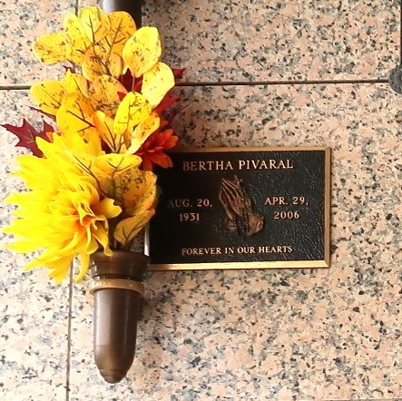

Bertha Sanchez Pivaral, on Saturday, April 29, 2006, at 7:20 P.M. Beloved wife of Oscar Pivaral. Mother and Mother-in-law of Lissette and Steven Smith, Robert and Kari Pivaral and Wendy and Carl Rapp. Grandmother of Sara Smith, Alissa and Leana Pivaral. Daughter of the late Brigido and Clemencia Solis Sanchez. Sister of Carlos Sanchez and the late Armando and Baby Sanchez. Cousin of Maria Elena Munoz. Age 74. A native of Guatemala, and a resident of Laplace, LA for the past 41 years. Relatives and Friends of the Family, also Members of the St. Joan of Arc Spanish Rosary Group, are invited to attend services. Visitation at MILLET-GUIDRY FUNERAL HOME, 2806 West Airline Hwy., Laplace, LA, on Wednesday, May 3, 2006, from 5:00 P.M. to 9:00 P.M. and on Thursday, from 8:00 A.M. to 9:45 A.M. Followed by Religious Services at St. Joan of Arc Catholic Church, Laplace, LA, at 10:00 A.M. Private Burial to be held at a later date.
The Times-Picayune, New Orleans, Louisiana
May 2, 2006

