Rion Poindexter
February 12, 1984 – January 5, 2023
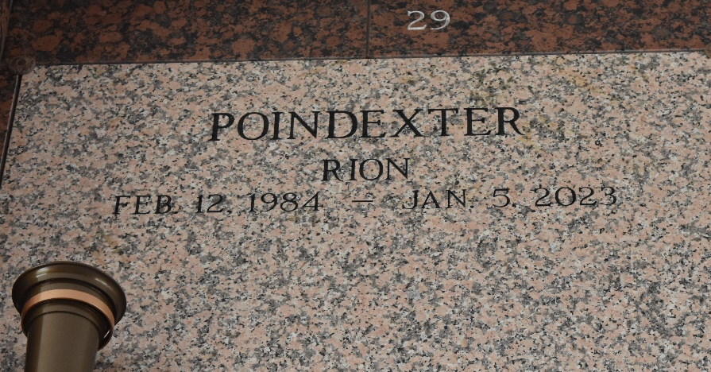

On January 5, 2023, God received His child to be with Him in perfect peace. Rion Poindexter was born on February 12, 1984, and was the only child of his loving parents Doris and Larry Poindexter. Rion resided in St. John Parish and was a graduate of East St. John High School. He attended Southeastern Louisiana University, and in June 2021 he proudly received his NCCER ELECTRICAL certification. Rion enjoyed cars, basketball, football, track, golf, and he was everyone's favorite storyteller. Rion was passionate about his work, very confident, tireless, and always the life of the party! Rion went on to save lives as a transplant organ donor of both kidneys, his liver, and his heart. He was also able to donate tissue cells for research.
In 2016, Rion joined YAMMS a young adult outreach ministry of Riverlands Christian Center. His parents witnessed a positive change; one of peace, purpose, and servanthood. Rion leaves treasured memories to be cherished with his parents Larry and Doris Poindexter; his children London, Ragan Renae, Rhian Monae; his bonus children Makayla & Maurice; his loving girlfriend Dianna Matthews; and a host of aunts, uncles, cousins, and friends. Rion will always be lovingly remembered and sorely missed.
A celebration of life honoring Rion Poindexter will be held on Saturday, January 21, 2023, at Riverlands Christian Center, 123 Redemption Way, Reserve, LA 70084. Visitation will begin at 12. Service will begin at 1 pm. Entombment to follow at St. John Memorial Gardens Cemetery in Laplace, La. Final care and professional services entrusted to Treasures of Life Funeral Services, 315 E Airline Hwy., Gramercy, LA 70052.
Treasures of Life Funeral Services, Gramercy, Louisiana

