Doris Mae (Dewey) Pollard
May 26, 1941 – November 3, 2019
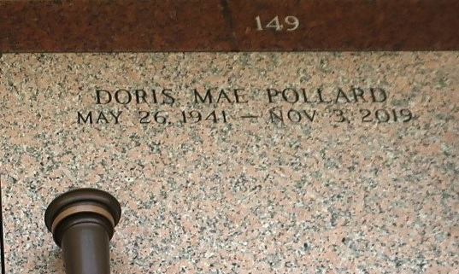

Doris Mae Pollard, a native of Norco, LA and a residence of LaPlace, LA, slept away peacefully at the age of 78 years on Sunday, November 3, 2019. Doris was a member of Good Hope Baptist Church of Norco, LA. Pastor D.B. Mollaire. Daughter of the late Romalis and Inez Dewey. Wife of the late Willie Pollard. Loving mother of Lisa Joseph, Tyrone, and Dwayne Dewey and the late Nolan and Reginald Dewey. She was also survived 17 grandchildren, 19 great-grandchildren, sisters, nieces, nephews, other relatives, and friends.
Pastors, officers, and members of The Greater Good Hope Baptist Church of Norco, LA, St. Martin Episcopal School, and all neighboring churches are invited to attend the homegoing celebration on Saturday, November 16, 2019 at 11:00 a.m. at the Greater Good Hope Baptist Church, 47 Cathy St., Norco, LA. Pastor Tyrone Scott officiating. Visitation will be at the Great Good Hope Baptist Church from 10:00 a.m. until service time. Interment in St. John Memorial Garden 2205 Airline Hwy. LaPlace, LA. Bardell's Mortuary of Mt. Airy, LA in charge. Information: (985) 535-6837.
The Times-Picayune (New Orleans, LA)
Nov. 15, 2019

