Lennie P. Ponville
November 2, 1977 – May 29, 2018
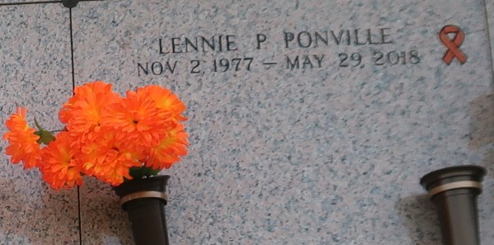

Lennie Paul Ponville born in New Orleans died at the age of 40 at home in LaPlace, LA on May 29, 2018. He is survived by his Wife, Lisa Cooke Ponville; Stepchildren, Airel Cooke and Ivan Gould, Jr. (Nicole); Dad, CJ Trosclair; Step-Mom Rose; Godchildren, Chelsea Cooke, Dominic Cooke, and Nathan Cooke; Step-Grandchildren, Ivan Gould, III and David Gould; and several other relatives. Preceded in death by his Mother, Mary Ann Ponville and Grandparents, Fred and Dorothy Trosclair.
Relatives and friends are invited to attend the visitation and service at Millet-Guidry Funeral Home, 2806 W. Airline Hwy., LaPlace on Saturday, June 2, 2018 from 10:00 a.m. to 2:00 p.m. To view or sign the online guest book, please visit www.milletguidry.com.

The New Orleans Advocate, Louisiana
May 31 to Jun. 2, 2018

