Lois Ann (Guillot) Ponville
November 27, 1941 - September 11, 2019
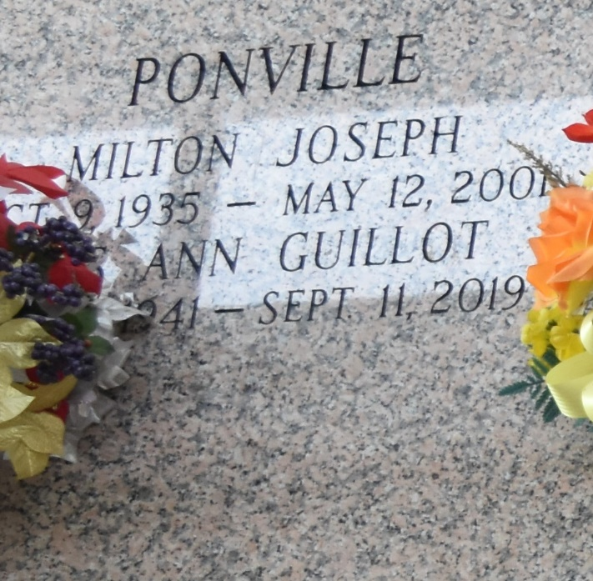

Lois Ann Ponville, passed away on Wednesday, September 11, 2019, at the age of 77. She was a native of Norco, LA and resident of LaPlace, LA.
She was the beloved wife of the late Milton Joseph Ponville. Mother of Ronald Joseph Ponville, Melissa Ann Zulli (Kevin), and Patricia Ann Templet (Eric). Grandmother of Luke Rhys Ponville, Kayla Ann Zulli, Katie Rose Zulli, Hannah Grace Templet, and Nicholas Aaron Templet. Sister of Marie Ann Ruberstell, Yulone Hebert, Jeanne Bates, Emilie Yokum, and Gary Guillot. Also survived by many nieces and nephews.
She was preceded in death by her parents, Cecile Cambre Guillot and Ulysse Guillot and her siblings, Bryan Guillot and Carroll Guillot.
Relatives and friends are invited to attend the Funeral Mass at Ascension of Our Lord Catholic Church, 799 Fairway Dr., LaPlace, LA 70068, on Saturday, September 14, 2019 at 11:00 A.M. The visitation will begin in church at 9:30 A.M. Interment to follow at St. John Memorial Gardens Cemetery.
Arrangements by Millet-Guidry Funeral Home.

Millet-Guidry Funeral Home, LaPlace, LA
September 19, 2019

