Curtis Joseph Porche
August 27, 1940 – October 30, 2012
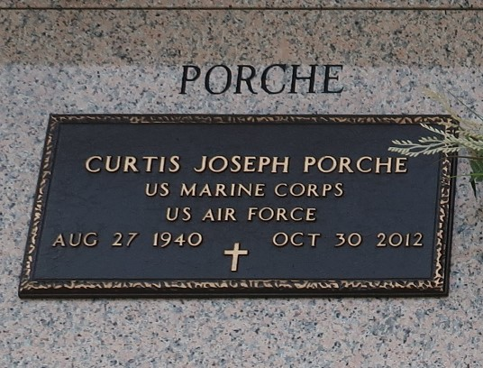

Rev. Curtis J. Porche passed away on Tuesday October 30, 2012. Beloved husband of Margaret Lightell Porche. Father of Carl Porche (Dianna), Lydia LeFebvre (Steven), Brian Porche (Joannie) and Glenn Porche (Angie). Also survived by 17 grandchildren and 3 great-grandchildren. Son of the late Lucius and Louise Porche. Brother of Thomas and Darryl Porche and the late Glenn and Donald Porche. He was the Pastor of The First Assembly of God Church in LaPlace, LA for 23 years. Age 72. A native of Metairie, LA and a resident of Albany, LA.
Relatives and friends are invited to attend services. Visitation at The First Assembly of God Church, 3001 Hwy 51, LaPlace, LA on Friday November 2, 2012 from 5:00pm to 9:00pm and on Saturday November 3, from 9:00am to 11:00am, followed by Services at 11:00am. Burial in St. John Memorial Gardens, LaPlace, LA.

The Times-Picayune, New Orleans, Louisiana
Oct. 31 to Nov. 2, 2012

