Tiffany Deshawn Porter
January 9, 1979 – June 6, 2018
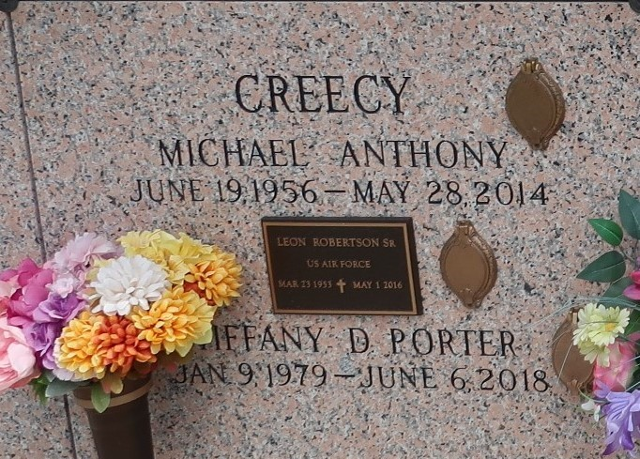

Tiffany Deshawn Porter, age 39, departed this life on Wednesday, June 6, 2018. Daughter of Beverly Robertson Creecy and Huey J. Porter, and stepdaughter of the late Michael A. Creecy, sister of Kentrell Douglas and Ireial Lennix, step sister of Marquesha Creecy, Goddaughter of Claudia Farlough and Calvin Robinson, Sr. Tiffany is survived by a host of aunts, uncles, nieces, nephews, cousin and friends.
Celebration Service will be on Saturday, June 16, 2018 at Pilgrim B.C. 107 Pilgrim Dr. Reserve La, at 12:00 noon. Rev. Dr. Forell Bering Officiating. Interment in St. John Memorial Gardens, 2205 W. Airline Hwy., Laplace LA., Pilgrim B.C., Zion Travelers., Beech Groove B.C., and all neighboring churches, East St. John High School Class of 2001, St. John Parish School Board, Cargill Grain, Care, INC., Ochsner-Kenner, Doctors and staff of the 2nd, 4th, and 5th floor of Ochsner Jefferson, Eagan Home Care are invited to attend celebration. Visitation at the above name funeral home on Friday June 15, 2018 from 5pm-7pm and at Pilgrim B.C. on Saturday from 10am until service time. (ONLY) Professional Services entrusted to the caring staff Hobson Brown Funeral Home, 134 Daisy St., Garyville, La 70051, (985) 535-2516.
TheNewOrleansAdvocate.com
June 13 to June 16, 2018
Contributed by Jane Edson

