Marian (Clement) Prudhomme
October 21, 1930 – December 6, 2020
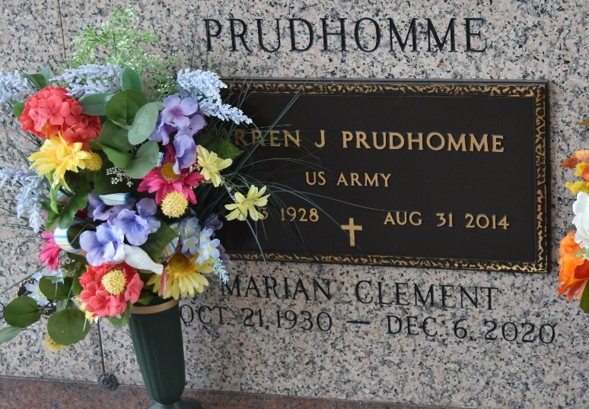
Marian Clement Prudhomme passed away peacefully at her residence surrounded by family on Sunday, December 6, 2020 at the age of 90. She was a native and lifelong resident of LaPlace, LA. Beloved wife of the late Warren "Zon" Prudhomme. Loving mother of Paula P. Haydel (Lester), Perry J. Prudhomme, Sr. and Tammy P. Portera (the late, Tim). Grandmother of Lester Haydel, III (Beckie), Heather H. Alvarado (John-Michael), Kyle Haydel, Perry J. Prudhomme, Jr. (Michelle), Mandy Moreira (Ricardo), Raelyn Dempster (Blake), Dayton Prudhomme, Amber Portera and Wyatt Portera. Great grandmother of Carleigh, Cooper, Connor, Jude, Annamarie, Nathan and Noah. Daughter of the late Lawrence "Loule" Clement and Simone Vicknair Clement. Sister of Faye Clement Marse (Kenneth, Sr.) and the late Lorraine Clement, Lawrence J. "L. J." Clement, Jr., Lillie Mae Clement, Harold Clement, Dwight Clement, Sr., and Daniel Clement. Also survived by many nieces and nephews.
The family would like to give a special thanks to her care takers, Iris, Emily, Ruby and Brenda. A Private Graveside Service will be held in St. John Memorial Gardens Cemetery.
Millet-Guidry Funeral Home, LaPlace, Louisiana
December 10, 2020

