Warren J. Prudhomme
1928 – August 31, 2014
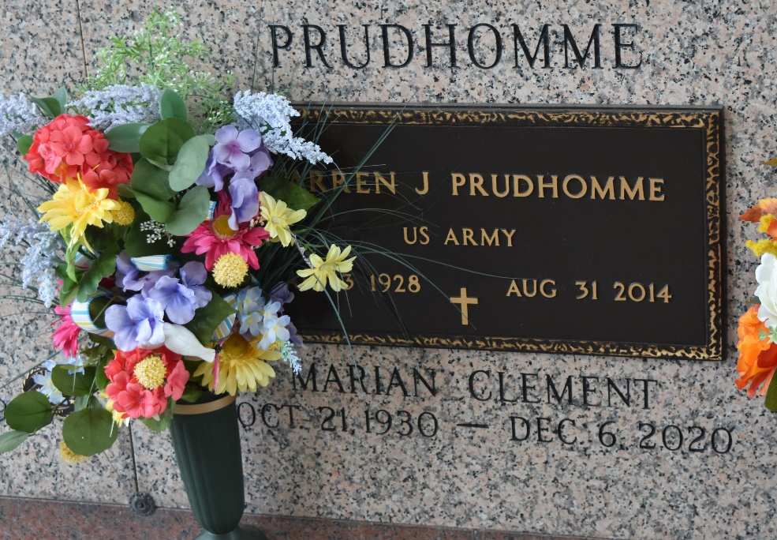

Warren J. (Zon) Prudhomme died on Sunday August 31, 2014. Beloved husband of Marian Clement Prudhomme. Father of Paula P. Haydel (Lester), Perry Prudhomme (Friend Betty) and Tammy P. Portera (Tim). Grandfather of Lester III, Heather and Kyle Haydel, Perry Jr., and Dayton Prudhomme, Mandy Moreira and Raelyn Dempster and Amber and Wyatt Portera. Great-grandfather of Carleigh Haydel. Son of the late Nealon and Palmyre Brady Prudhomme. Brother of Nealon Prudhomme Jr., and the late Richard (Cha) Prudhomme. Age 86. A native and resident of LaPlace, LA. He was an Army Veteran and retired from Shell Oil Refinery.
Relatives and friends are invited to attend services. Visitation at Millet-Guidry Funeral Home, 2806 W. Airline Hwy., LaPlace, LA on Tuesday September 2, 2014 from 8:00am to 10:00am, followed by Religious Services in the Funeral Home Chapel at 10:00am. Burial in St. John Memorial Gardens Cemetery, LaPlace, LA.

The New Orleans Advocate, Louisiana
Aug. 31 to Sep. 1, 2014

