Stephanie (Baloney) Pryor
June 18, 1966 – May 14, 2005
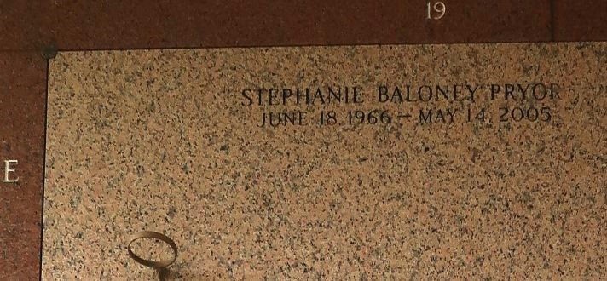

Stephanie Denise Baloney-Pryor, a teacher's assistant with the Title One Program at Our Lady of Grace and St. Peter Catholic Schools, went to be with the Lord on Saturday, May 14, 2005 at Methodist Hospital, New Orleans. Beloved daughter of Karen C. Baloney and the late Earl Baloney, Jr., Step-daughter of Shelia G. Baloney. Beloved wife of Makale Pryor. Beloved mother of Gabrielle, Makelle and Jared Pryor. Grandmother of Jerriya Anderson. Beloved sister of Valerie B. Johnson of Columbus, GA, Helaine Baloney of Cincinnati, Ohio, and Courtney Baloney of Garyville, LA. Granddaughter of Ophelia Baloney and the late Earl Baloney, Sr., Katie and Charles Baxter and Robert Canida. Devoted niece of Carl, Carmen Baloney, Alona McDowell, Judy Morris, Sharon Hill, Anita Martin, Kay Scott and the late James Canida. Also survived by a host of aunts, uncles, nieces, nephews, cousins and friends. A native of Garyville and a resident of Laplace, LA, Age 38 years.
Relatives and friends of the family, also pastor, officers and members of Bethlehem Baptist Church, New Pilgrim Baptist Church, True Light Baptist Church, Our Lady of Grace Catholic Church and neighboring churches, employees of Our Our Lady of Grace and St. Peter Catholic Schools, Cargill Grain Elev., The Baloney Funeral Home, and St. John Parish School System are invited to attend the funeral services on Thursday, May 19, 2005 at 11:00 AM from the New Pilgrim Baptist Church, 107 Pilgrim Dr., Reserve, LA. Rev. Dr. Forell Bering, officiating. Entombment St. John Memorial Gardens Mausoleum, Laplace, LA. Visitation on Wednesday, May 18, 2005 4-8 PM from the Baloney Funeral Home, 399 Earl Baloney Dr., Garyville, LA and on Thursday after 9:00 AM at the church. THE BALONEY FUNERAL HOME in charge of arrangements.

The Times-Picayune, New Orleans, Louisiana
May 18, 2005

