Alvin James Quigley
December 29, 1929 – March 19, 2018
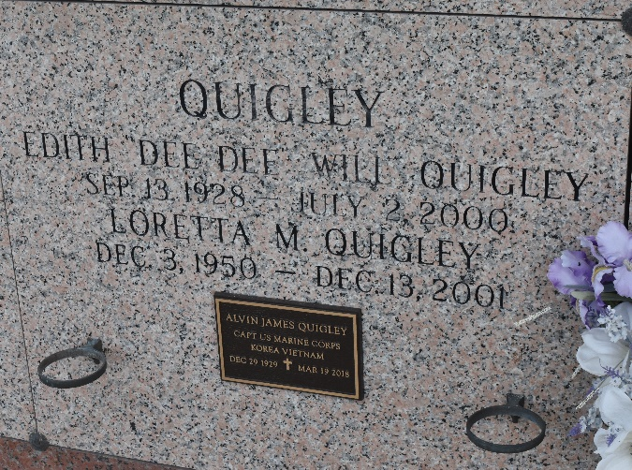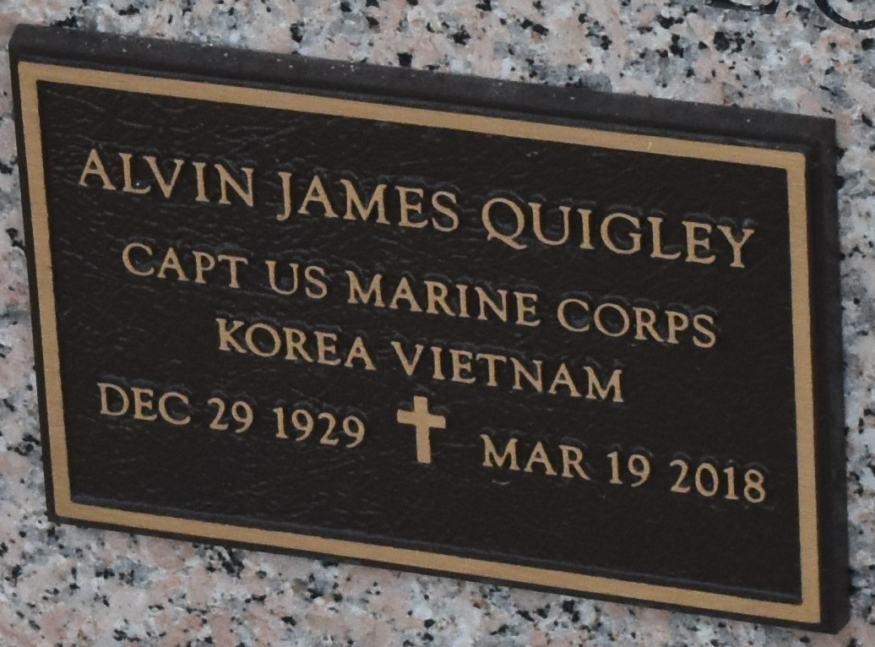
“OUR COUNTRY IS IN MOURNING FOR A MARINE DIED TODAY”

Alvin J. Quigley, CAPT. USMC (RET), born December 29, 1929, received his final orders to report to Paradise Island, Heaven, on March 19, 2018. Waiting for Alvin to arrive were his loving wife, Edith V. “Dee Dee” Will Quigley; only daughter, Loretta May Quigley; parents, Malvin M. Quigley and Marguerite DiPrimo Quigley; brother, Justin J. Quigley; sisters, Sister Mary Andre Lois Quigley and Roselyn Theresa Quigley; and sister-in-law, Jean Green Quigley. Alvin left behind sister, Josephine “Josie” Q. Ruiz; brothers, Francis “Frank” Quigley and Alan M. Quigley; sisters-in-law, Lois D. Quigley, Daryl M. Quigley and Pam W. Carlton; brother-in-law, Steve Carlton; also nephews, nieces and friends.
Alvin was born a Marine, lived a Marine and passed to his final deployment a Marine.
Relatives and friends are invited to attend the visitation at Millet-Guidry Funeral Home, 2806 W. Airline Hwy., LaPlace on Friday, March 23, 2018 from 9:00 a.m. to 11:00 a.m. followed by the Funeral Mass at 11:00 a.m. Interment will follow with military honors in St. John Memorial Gardens Cemetery.

Millet-Guidry Funeral Home, LaPlace, Louisiana
March 21, 2018

