Clara Ann (Sterling) Radcliff
April 26, 1948 – June 12, 2021
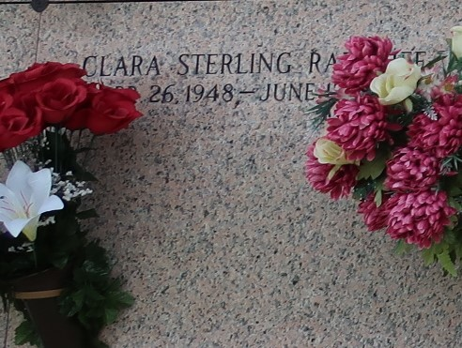

Clara Ann Sterling Radcliff was born on April 26, 1948, in New Orleans, LA to the union of the late Alfred Sr. and Lillian Sterling. Clara departed this earthly life on Saturday, June 12, 2021 at Ochsner Hospital in Jefferson, LA.
Clara leaves to cherish her memories, her loving daughter and son-in-law, Andrea and Timothy Francois Sr.; sisters, Peggy Bradford, Deborah Martin, and Jo Ann Levi; brothers, Donald Noel Sr., Harold Sterling Sr., and Alfred Sterling Jr.; brother-in-law, Cecil Martin; sisters-in-law, Mona Noel and Kay Sterling; nieces and nephews, Anita, Donald Jr., Kendell, Wendell, Harold Jr., Candace, Tiran, Jarrad, Godfrey, Tennia, Jason, Latanya, Jeneane, Ryan, Brandi and Victoria; and a host of other relatives and friends.
Public visitation will be held on Thursday, June 17, 2021, from 5:00 pm to 7:00 pm at Treasures of Life Funeral Services, 315 E. Airline Hwy., Gramercy, LA 70052. A Mass of Christian Burial will be held Friday, June 18, 2021, at 10:00 am at Our Lady of Grace Catholic Church, 780 Hwy. 44, Reserve, LA 70084. Visitation will begin at 8:15 am and the Rosary will be recited at 9:15 am. Interment will follow at St. John Memorial Gardens, 2205 W. Airline Hwy., Laplace, LA.

Treasures of Life Funeral Services, Gramercy, Louisiana

