Donna (Madere) Ramirez

July 10, 1950 – June 19, 2016

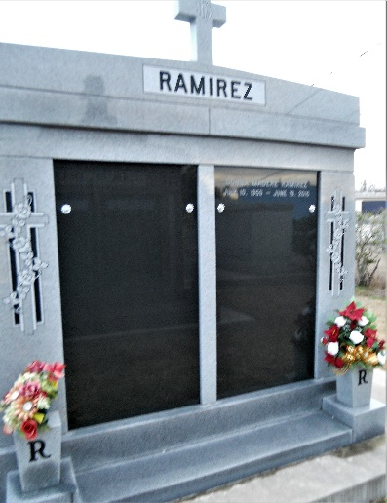 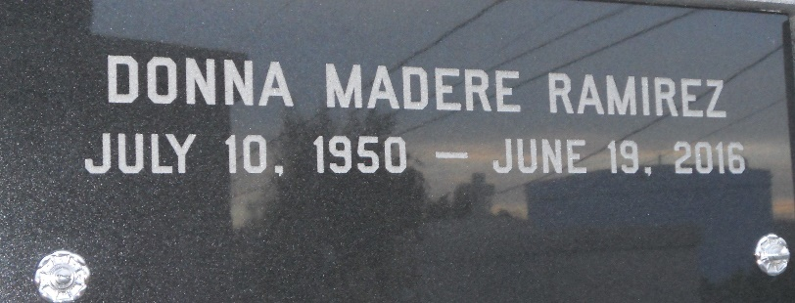

Photos by Team T-Lo

Donna Madere Ramirez, 65, of LaPlace, was welcomed into heaven on the evening of Sunday, June 19th, 2016. She was born on July 10th, 1950 to the late Clarence Kye Madere Jr. and Teresa Aycock Madere who are undoubtedly holding her joyfully in their arms again.  
 After a long fought battle with Lewy Body Dementia, Donna finally found the peace she longed for in the comfort of her LaPlace home surrounded by the love of her family. Even through her many challenges Donna's faith was unwavering and inspiring. She was a devout Catholic and beloved wife & mother.  
 She leaves her loving memories to be cherished by her husband of 35 years David Ramirez; her four children – Casey Deaton, David Ramirez Jr., Ashley Deaton and Steven Ramirez; and 6 grandchildren – Avery Deaton, Riley Deaton, Zachary Deaton, Cohen Ramirez, Luke Ramirez and Julien Ramirez.  
 The family is deeply grateful for the outpouring of love, prayers and support from so many. A special thank you to doctors and caregivers - Dr. Julie Ceasar, M.D.; Dr. Michael V. Knight, M.D.; Dr. David Houghton, M.D., M.P.H.; Marie Joseph and LaShey Copelan.  
 Visitation will be held at Millet-Guidry Funeral Home (2806 W Airline Hwy, LaPlace, LA 70068) on Thursday, June 23rd from 6-9pm. Viewing will continue on Friday, June 24th at St. Joan of Arc Catholic Church (529 W 5th St, LaPlace, LA 70068) from 9:30-11am followed by an 11am funeral mass. Interment in St. John Memorial Gardens Cemetery.  
 Memorial gifts in Donna's memory can be made to the Lewy Body Dementia Association (www.lbda.org) 912 Killian Hill Rd SW, #103, Lilburn, GA 30047.

Millet-Guidry Funeral Home, LaPlace, Louisiana