Roswald Ramirez
July 15, 1972 – August 9, 2021

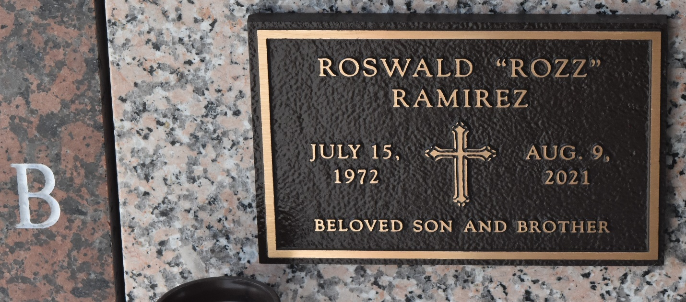

Roswald “Rozz” Ramirez passed away on Monday, August 9, 2021 at the age of 49. He was a native of New Orleans, LA and a resident of LaPlace, LA.
Beloved son of Cynthia Zamora Ramirez and the late Jorge E. Ramirez. Brother of James Ramirez (Beth) and the late Steve Ramirez . Also survived by nieces, Kai and Kali Ramirez, aunts, uncles and cousins.
Relatives and friends are invited to attend the Visitation and Memorial Mass at Millet-Guidry Funeral Home, 2806 W. Airline Hwy., LaPlace on Friday, August 13, 2021. Visitation from 2:00 p.m. to 4:00 p.m. followed by a Memorial Mass at 4:00 p.m.
To share a memory or leave condolences, please visit
www.milletguidry.com

Millet-Guidry Funeral Home, LaPlace, Louisiana

