Marbin Otoniel Ramos

March 15, 1973 – October 3, 2000

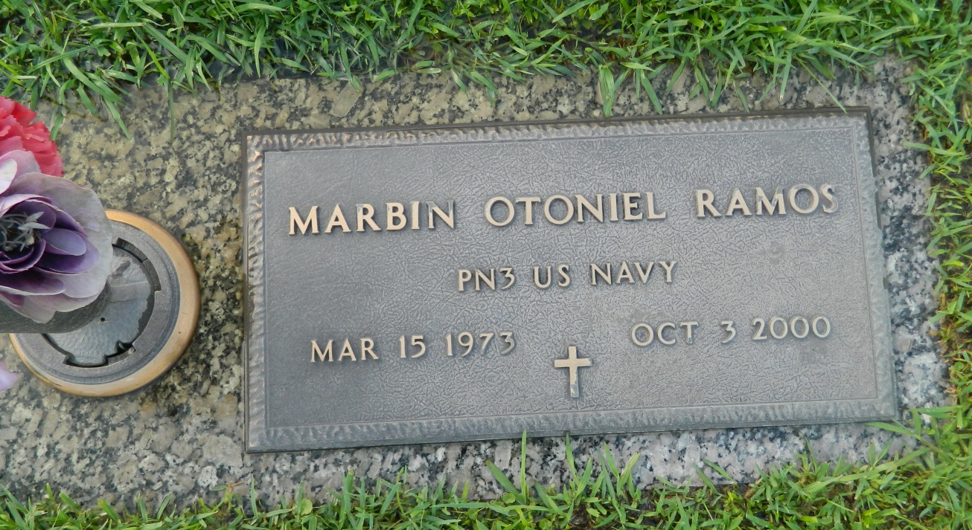

Marvin (sic) O. Ramos, an electrician, died Tuesday at River Parishes Hospital. He was 27. Mr. Ramos was born in Honduras and lived in LaPlace for 11 years. He served five years in the Navy. Survivors include a daughter, Destiny Ramos; his mother, Marta R. Garcia; his stepfather, Joel Garcia-Castillo; and a sister, Onoria Ramos de Portillo.

A funeral will be held Friday at 10 a.m. at Millet Guidry Funeral Home Chapel in LaPlace. Visitation will be today from 5 to 10 p.m. and Friday at 8 a.m. at the funeral home. Burial will be in St. John Memorial Garden.

Times-Picayune, The (New Orleans, LA) - Thursday, October 5, 2000

Contributed by Jane Edson