Edward C. Randall
February 8, 1955 – October 3, 2013

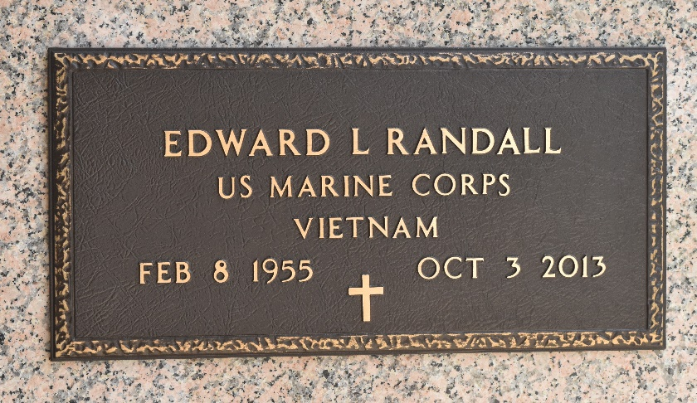

EDWARD C. RANDALL "EDDIE" on Thursday, October 3, 2013, at Baypine Medical Center, St. Petersburg, FL.
Son of the late Grace Douglas and Rayfield Lewis, Sr. Husband of the late Mary Randall. Father of Katrice Reid, Shenise Hatch, Raquel Joseph, Jonathan and Michaela Randall. Brother of Marvin, Rayfield, Jr., Percel, Vernon and Claude Lewis, Betty Jackson, Willie Doris St. Hill, Joann Haynes and the late Foster Lewis "Icewater". Also survived by 9 grandchildren and a host of nieces, nephews, cousins, other relatives and friends. Age 58 years. A native of New Sarpy, LA and resident of St Petersburg, FL
Relatives and friends of the family are invited to attend the Funeral Service at Robottom Mortuary, 850 Hwy 44, Reserve, LA on Saturday, October 12, 2013, at 10:00 AM. Rev. Melvin Hurst, Officiating, Pastor of Guiding Light Missionary Baptist Church of Kenner, LA. Interment St John Memorial Garden Cemetery, LaPlace, LA. Visitation at the above-named funeral home from 9:00 AM until Service Time.

The Times-Picayune, New Orleans, Louisiana
October 10 & 11, 2013

