Garland Troy Randall

March 2, 1975 – December 18, 2011

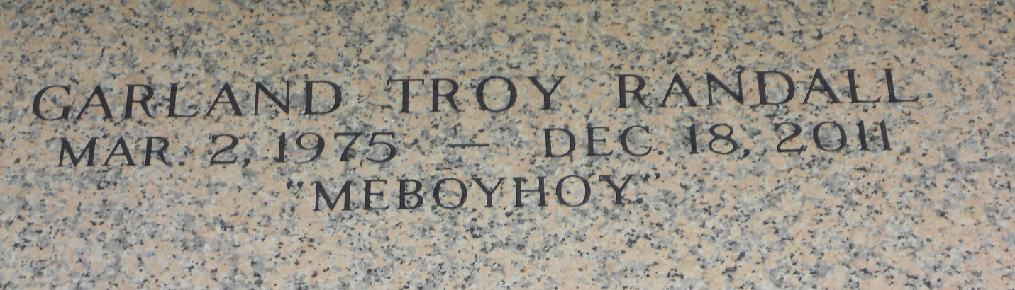

Photo by Team T-Lo

Garland Troy Randall Age 36 departed this life on Sunday December 18, 2011, in New Orleans, La., Son of Joyce Randall and the late Wilfred Randall, Father of Keelan Jackson, Troyvianne, Troyland, and Troy'Daz Randall, Brother of Sybil, Monique and Terri Randall, Nephew of Dorothy Williams, Linda Joseph, and Avis Johnson Also survived by a host of Uncles, Nieces, Nephews a devoted friend Ashley Collins, other relatives and friends.

Funeral services on Friday December 23, 2011 at 11:00am at New Wine Christian Fellowship 1829 west airline Highway Laplace, La., Rev. Neil Bernard Officiating, Burial in St. John Memorial Cemetery, Visitation at church from 9:00a.m. Until Service time. (ONLY) Rising Star B.C. and all neighboring churches, Employees of Millet Enterprise, Dillard's Lakeside, Subway- Kenner Location and Louisiana Sugar refinery- Gramercy are invited to attend services. Services Entrusted to Hobson Brown Funeral Home Garyville, La 70051 985-535-2516.

Published by Legacy Remembers

Dec. 21 to Dec. 22, 2011