Roger Louis Rapp
February 8, 1922 – February 19, 2006

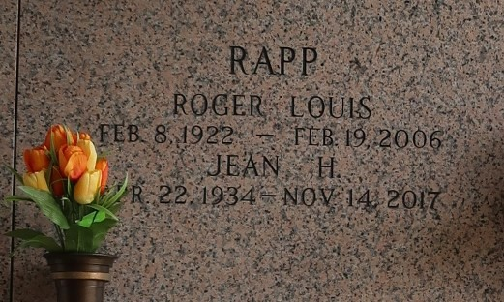

Roger L. Rapp, on Sunday, February 19, 2006 at 2:40 a.m.
Beloved husband of Jean Hartman Rapp. Uncle of Janice Schiro. Great Uncle of James Schiro. Age 84. A native of New Orleans and a resident of Laplace for the past 53 years.
Relatives and friends of the family are invited to attend services. Visitation at Millet-Guidry Funeral Home, 2806 W. Airline Hwy, Laplace, on Tuesday, February 21, from 10 am until 12 noon. Followed by religious services at the funeral home chapel. Burial in St. John Memorial Gardens, Laplace.

The Times-Picayune, New Orleans, Louisiana
February 21, 2006

