Danielle (Marks) Rebstock
December 30, 1979 – July 24, 2017

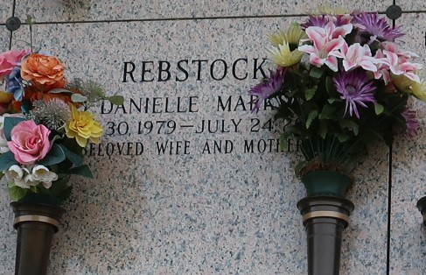

Danielle Marks Rebstock passed away on Monday, July 24, 2017. She was 37, born in Metairie, LA and was a resident of LaPlace, LA.
Beloved wife of Daren Rebstock. Loving mother of Celeste and Caitlin Rebstock. Daughter of Eula Stoute Marks and the late Ronald Marks. Sister of Phyllis Laurent (Stephen), Josh 'Toby' Marks (Kila), Thomas 'Kevin' Marks (Cynthia), Chantel 'Nikki' Fazzio (Tony) and the late Brian 'Kent' Marks. Also survived by many nieces and nephews. Danielle will be sadly missed by her family, friends and all who viewed her as their 'neighborhood mother'.
Relatives and friends are invited to attend the Funeral Service at Millet-Guidry Funeral Home, 2806 W. Airline Hwy., LaPlace on Saturday, July 29, 2017 at 12:00 p.m. Visitation from 9:00 a.m. until 12:00 p.m. Interment in St. John Memorial Gardens Cemetery. To view or sign the online guest book, please visit www.milletguidry.com

The New Orleans Advocate, Louisiana
Jul. 27 to Jul. 29, 2017

