Carl Leo Reed Jr.

August 1, 1939 – December 25, 2011

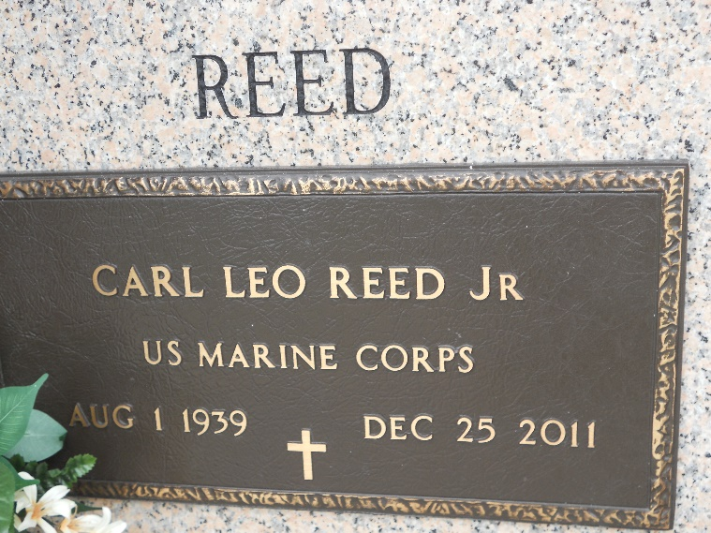

Photo by Team T-Lo

Carl Leo Reed, Jr. passed away on Sunday, December 25, 2011. Beloved husband of Sandra S. Reed. Father of Kevin and Jeffery Reed, Craig Reed (Leigh) and Lisa Vinson (David). Grandfather of Corey, Krista, Katelyn, Matthew, Anna, Kimberly and Ian. Son of the late Carl and Anna Lee Reed. Brother of Rene, Freddie and Steve Reed and Carla Buck. Brother-in-law of John and Linda Szczepanik. He was a veteran of the U. S. Marine Corp. Age 72 years. A native of Oberlin, LA and a resident of LaPlace.

Relatives and friends are invited to attend services. Visitation at St. Joan of Arc Catholic Church, LaPlace on Thursday, December 29, 2011 from 9:15 AM until 11:00 AM, followed by a Mass at 11:00 AM. Burial in St. John Memorial Gardens Cemetery, LaPlace, LA. In lieu of flowers, Masses or donations preferred to The [American Cancer Society](https://donate3.cancer.org/?campaign=legacy2&giftFirstName=Carl&giftLastName=Reed&giftType=mem). Arrangements by Millet-Guidry Funeral Home, LaPlace, LA.

The Times-Picayune, New Orleans, Louisiana

Dec. 26 to Dec. 27, 2011