Hazel (Watson) Reid
March 10, 1928 – October 31, 2014

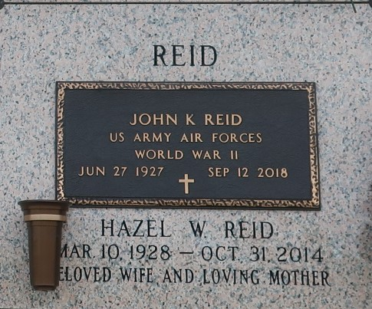

Hazel Watson Reid passed away on Friday, October 31, 2014 at the age of 86. She was a native of Groveton, TX and a resident of LaPlace, LA since 1977.
She was preceded in death by her parents, William Valton Watson and Ione Hayes Watson; brothers, Valton Junior, Louis Leon and Thomas Murphy Watson; and sister, Dorothy Watson Hawes. She leaves behind her two devoted care givers, Kathy Hampton and Samantha Montgomery.
Relatives and friends are invited to attend the Funeral Service in the Chapel of Millet-Guidry Funeral Home, 2806 W. Airline Hwy., LaPlace on Thursday, November 6, 2014 at 11:00 a.m. Visitation will begin at 10:00 a.m. Interment in St. John Memorial Gardens Cemetery.
TheNewOrleansAdvocate.com
Nov. 2 to Nov. 5, 2014

