John Kirkland Reid
June 27, 1927 – September 12, 2018

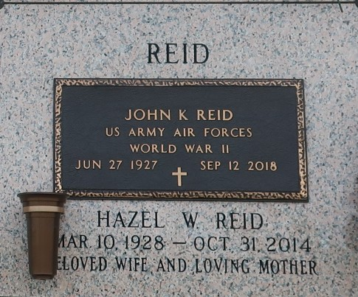

Visitation: September 17, 9:00 AM - 11:00 AM; Millet-Guidry Funeral Home; 2806 West Airline Highway; LaPlace, LA, US, 70068

Service: September 17, 11:00 AM; Millet-Guidry Funeral Home

Burial: St. John Memorial Gardens Cemetery; 2205 W. Airline Hwy.; LaPlace, LA, 70068

