Wanda (Lewis) Reid
September 12, 1949 – November 17, 2023

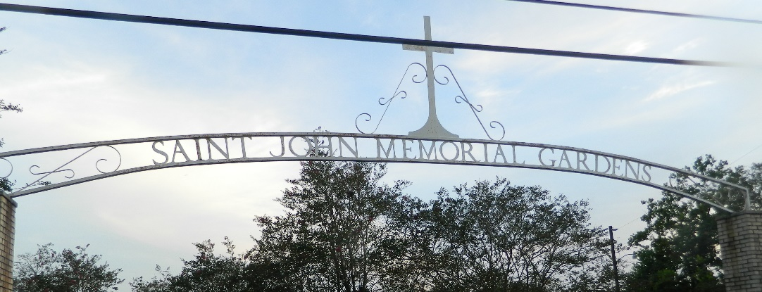

Wanda Lewis-Reid walked away with God on Friday, November 17, 2023. She was born September 12, 1949, in New Orleans, LA, to the late Joseph and Elizabeth Lewis. Wanda Lewis Reid was married to the late Harry Lee Reid, Sr., and to this union five children were born.
Wanda leaves to cherish her memories: her children, Cynthia Reid-Arceneaux, Lisa Reid Cobb (Roderick), Sandra Maria Reid, Harry L. Reid, Jr., and Sabrina Reid-Narcisse (Ronnie), grandchildren, and great-grandchildren. She also leaves to mourn her sisters, brothers, family, church members, and friends.
Wanda Lewis Reid was preceded in death by her late husband, Harry Lee Reid, Sr.; and parents, Joseph and Elizabeth Lewis.
Family and friends are invited to the homegoing celebration on Saturday, November 25, 2023, at 11 a.m. at St. Michael Baptist Church, 701 Colony Park Dr., LaPlace, LA 70068. Visitation will be from 10 a.m. until service time. Interment: St. John Memorial Gardens, LaPlace, LA.
The Times-Picayune, New Orleans, Louisiana
Nov. 23 to Nov. 24, 2023

