David Harrison Revolta
December 11, 1974 – July 30, 2017

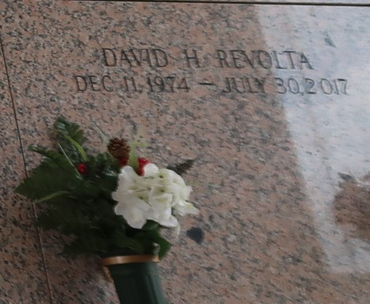

David H. Revolta passed away on July 30, 2017. He was 42, a native of New Orleans, LA and a resident of LaPlace, LA.
Beloved dada of Maddi Revolta. Son of Sharon C. Harrison and Joseph Revolta. Brother of Josh Revolta (Lisa) and Nanci Revolta Dozier (Vincent). Step-brother of Sabrina Moldaner Primes (Chad) and Daniel Moldaner. Uncle of Gabrielle, Dylan, Ella, Mason, Davon and Carley. Also survived by many relatives and friends.
Relatives and friends are invited to attend the Funeral Mass at Ascension of Our Lord Catholic Church, 1900 Greenwood Dr., LaPlace, LA on Saturday at 12:00 p.m. Visitation from 10:00 a.m. until 12:00 p.m. Interment in St. John Memorial Gardens. To view or sign the online guest book, please visit www.milletguidry.com
The New Orleans Advocate, Louisiana
Aug. 2 to Aug. 5, 2017

