Joseph Harry Revolta
December 11, 1974 – July 30, 2017

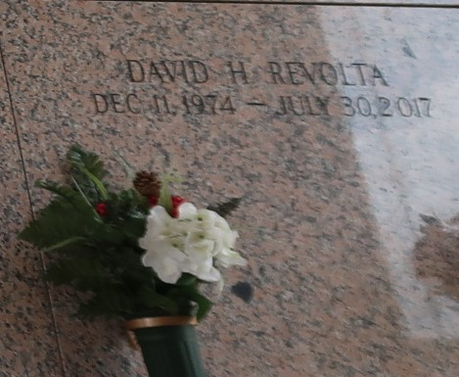

Joseph Harry Revolta, a resident of LaPlace, LA, passed away on Tuesday, November 21, 2023 at the age of 73.
Joseph proudly served in the US Navy from 1969-1972. He was an avid golfer and "retired" from bowling after his perfect game.
Beloved husband of the late Stephanie "Stevie" Revolta. Loving father of Nanci Dozier (Vincent), Josh Revolta (Lisa) and the late David Revolta. Stepfather of Sabrina Primes and Daniel Moldaner. Grandfather of Gabrielle, Dylan, Ella, Mason, Davon, Carley, Delilah, Brayden, Maddi, Scarlett, and CJ. Son of the late Earl and Beverly Manchardt Revolta. Brother of Sylvia Kimbell (Wayne), Earl "EJ" Revolta, Susan Hock (Warren), the late Sandra Jimmerson (the late John). Also survived by the mother of his children Sharon Harrison, numerous nieces, nephews, cousins, and friends.
Private inurnment will be held. A Celebration of Life will be scheduled at a later date. Arrangements by Millet-Guidry Funeral Home. To share memories or condolences, please visit www.milletguidry.com
Obituary published on Legacy.com by Millet-Guidry Funeral Home
Nov. 22, 2023

