Stephanie (Restel) Revolta

March 21, 1963 – July 13, 2005

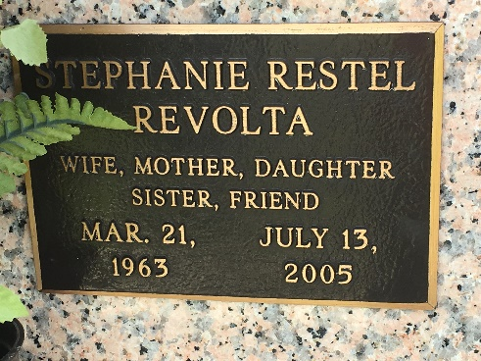

Photo by Team T-Lo

JEFFERSON – A shooting at Wholesale Siding Supply in Elmwood resulted in the murder of a LaPlace resident and her co-worker, before the gunman shot himself. A 911 emergency call was received around 3:30 p.m. Wednesday from LaPlace resident Stephanie Revolta, 42, an office manager, when data entry clerk Barbara Cavalier’s husband, Chris Cavalier, entered the business after harassing his wife at work all day by repeatedly calling her, according to Col. Robert Garner with the Jefferson Parish Sheriff’s Office. Garner confirmed that Barbara and Chris had been married for seven years and she left him six months ago and he had no idea where she lived, but did know where she worked. It was said, by the Owner of the business Billy Deckwa Jr., that Chris came into the business and told Barbara she was going to die that night and so was he.

Deckwa reportedly said he was held hostage by Chris, who appeared to be intoxicated, but later let go, because Chris said he was not angry with him. Revolta stayed to try to help defend Barbara, but Chris told Barbara he was going to shoot Revolta and he did, confirmed Garner. Garner said that when the Sheriff’s Office SWAT team showed up, they heard many gunshots and that Chris fired upon officers at least once. By the time they went inside, all three were dead. Revolta’s body was found on the ground by the front door of the business. Barbara and Chris were in the office, Barbara on the floor and Chris was leaning against a desk with a gunshot wound to the head, confirmed Garner. “Chris came in with two weapons,” Garner said. “He had a .45-caliber automatic pistol and a .357-caliber Magnum revolver.” Revolta’s mother, Nita Restel of LaPlace, said she doesn’t know how someone who was drunk ended up with two lethal weapons. “It was Stevie’s nature to help,” Restel said. “That is what we called Stephanie. I feel angry, because I don’t understand why Barbara’s husband wasn’t stopped before, considering he was abusive. Why was there no restraining order?” Restel said Revolta had been working at the business for seven years and was a part of a close company that had many functions. “She was so generous,” Restel said of her daughter said. “She was devoted to her husband and her children. She had a son, Daniel Moldaner, and a daughter, Sabrina Moldaner. She married Joe Revolta six and a half years ago.” Revolta grew up in Harahan and attended Archbishop Chapelle High School. She later moved to St. Charles Parish, then to LaPlace, where she lived for the past five years, according to Restel. “Daniel is a deputy at St. Charles Parish Sheriff’s Office,” she said. “Sabrina just graduated from Destrehan High School and will begin as a freshman at UNO. Sabrina graduated with honors and received a Decennial Scholarship.” Revolta had two older brothers, making her the only daughter and “their princess,” Restel said. “She was so beautiful, bright and happy,” Restel said. “She loved animals. When she was young she would collect frogs, all kinds. Stevie’s friend, Terri, she met on her first day of high school at the bus stop called me and was devastated, because they had remained close all these years. She told me she was going to buy a big frog and put it in her front yard, so her friend would always be with her.” Funeral arrangements have tentatively been scheduled July 18 at Millet-Guidry Funeral Home in LaPlace.

L’Observateur, Laplace, Louisiana

Monday, July 18, 2005

\*\*

Stephanie (Stevie) Restel Revolta on Wednesday, July 13, 2005. Wife of Joseph H. Revolta. Mother of Daniel R. Moldaner and Sabrina A. Moldaner. Stepmother of David, Joshua and Nanci Revolta. Stepgrandmother of Mason Revolta. Daughter of James D. and Wunita Restel. Sister and sister-in-law of James Jr., Marianne Restel and Michael and Lynn Restel. Sister-in-law of Wayne and Sylvia Kimball, E.J. Revolta, Jr., John and Sandra Jimerson and Susan Warner. Also survived by aunts, uncles, cousins, nieces and nephews.

She attended St. Rita's School, Harahan, LA, Archbishop Chappelle High School and received a B.A. from UNO. A member of the Bumper to Bumper Bowling League and the Office Manager for Wholesale Siding and Supply Company, Jefferson, LA. Age 42 years. A native of Lafayette, LA and a resident of LaPlace, LA for the past 5 years.

Relatives and friends of the family are invited to attend services. Visitation at MILLET-GUIDRY FUNERAL HOME, 2806 W. Airline Hwy., LaPlace, LA on Monday, July 18, 2005 from 9:00 a.m. until 11:00 a.m. Followed by Religious Service at the Funeral Home Chapel at 11:00 a.m. Burial to be private at a later date.

The Times-Picayune, New Orleans, Louisiana

Jul. 17, 2005