Kevin J. Richoux

February 2, 1964 - March 17, 2019

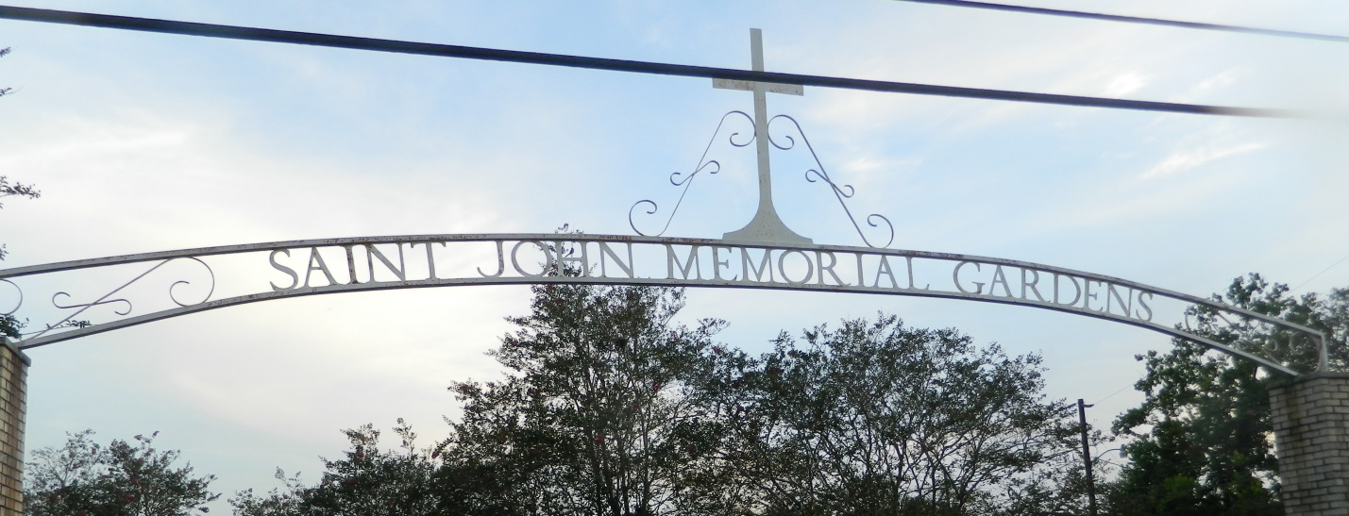

Kevin J. Richoux passed away at his residence surrounded by family on Sunday, March 17, 2019 at the age of 55. He was born in New Orleans and was a lifelong resident of LaPlace. Kevin was employed with Southwest Airlines for 30 years and was a devoted parishioner of St. Joan of Arc Catholic Church.

Beloved father of Thomas R. Evans. Preceded in death by his father, Robert E. Richoux. Loving son of Yvonne Duhe Richoux (companion, Maurice L. “Mr. Mo” Bourgeois). Brother of Rory E. Richoux (Rosalie), Stacy M. Richoux (Mikie), and Rachel R. Roussel (Robbie). Uncle of Kelsey Richoux, Kyle Richoux, Grace Richoux, Cody Roussel and Brittnee Roussel.

Relatives and friends are invited to attend the Funeral Mass at St. Joan of Arc Catholic Church, 529 W. 5th St., LaPlace on Wednesday, March 20, 2019 at 12:00 p.m. Visitation will be held from 10:00 a.m. until 12:00 p.m. Interment to follow in St. John Memorial Gardens Cemetery.

Millet-Guidry Funeral Home, LaPlace, LA (accessed 3/19/2019)