Robert E. Richoux

October 3, 1934 – February 12, 2000

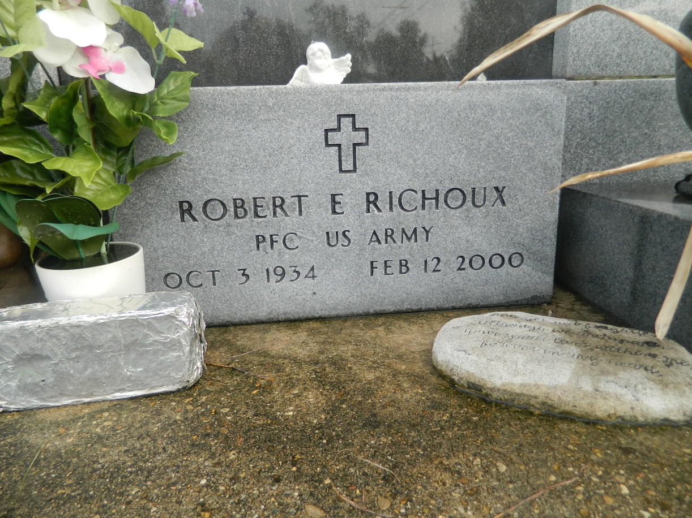

LAPLACE - Robert E. "Dit" Richoux, 65, a native and resident of LaPlace, died Feb. 12. He was the husband of Yvonne Duhe Richoux and father of Rachel Roussel and Rory, Kevin and Stacy Richoux.  
  
He was also the son of the late Lynwood and Lettie Hotard Richoux and brother of Ruby Englade.  
  
He is also survived by six grandchildren.  
  
Services were held Feb. 14 at St. Joan of Arc Catholic Church, LaPlace, with interment at St. John Memorial Gardens Cemetery, LaPlace.

L'Observateur (La Place, LA) - Wednesday, February 16, 2000

Contributed by Jane Edson