Charles Riley, Jr.
June 10, 1959 – January 4, 2021

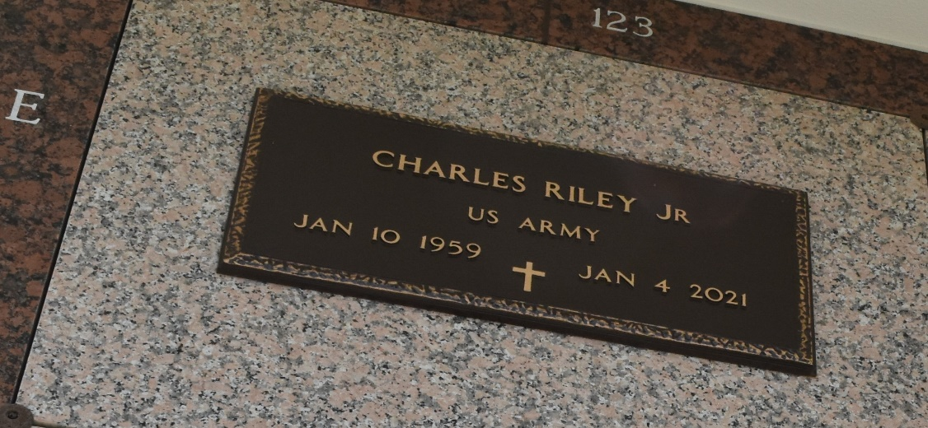

Charles Riley, Jr. departed this life on Monday, January 4, 2021. Son of Charles Riley, Sr and the Audrey Simms Riley, Husband of Hilda Frank Riley, Father of Derrick, Natasha and Keyrra Riley. Brother of Sybil Parquet, Shanika Ellis, Tyrone, Gerald, and Fernell Riley. Charles is also survived by his grandchildren, nieces, nephews, other relatives and friends.
Celebration Service will take place on Thursday, January 14, 2021 at 11:00 a.m. at Milesville Memorial Church of God in Christ, 129 Apple St, Laplace, La. Visitation on Wednesday January 13, 2021 from 5-7 and on Thursday at 10:00 a.m. until service time. (Only) Bishop Ronald Frank, Officiant. Interment in St. John Memorial Laplace, LA. Due to CDC (Covid-19) restrictions seating is limited, mask and social distancing are required. Professional Services entrusted to the Caring Staff of Hobson Brown Funeral Home, 134 Daisy St., Garyville, La 70051, 985-535-2516.
The Times-Picayune, New Orleans, Louisiana
Jan. 12 to Jan. 14, 2021

