Harry Robertson, Jr.
June 21, 1938 – July 15, 2012

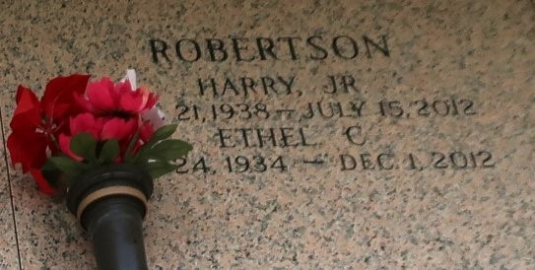

Harry (Puddin) Robertson, Jr., departed this life on Sunday, July 15, 2012 at the age of 74 years old. Son of the late Elnora and Rev. Harry Robertson, Sr. Husband of Ethel Carter Robertson. Father of Kevin (Vanessa) Roberston, Stephanie Duplessis, LeDene (Rodney) Bowie, Leonard Robertson, Kent Robertson, Kerry (Karen) Robertson. Also survived by a host of sisters, brothers, grandchildren, nieces, nephews, other relatives and friends.

Funeral services will be held on Friday, July 20, 2012 for 11:00 a.m. at New Pilgrim Baptist Church, 107 Pilgrim Street, Reserve, Louisiana. Viewing will be from 8:30 a.m. until time of service. Dr. Forel Bering will be officiating. Interment will be at St. John Memorial Gardens Cemetery. There will be a viewing at the Baloney Funeral Home on Thursday, July 19, 2012 from 12:00 p.m. until 5:00 p.m. Services entrusted to The Baloney Funeral Home, LLC. 399 Earl Baloney Street, Garyville, La. 985-535-2540.Condolences can be expressed at www.baloneyfuneralhome.com
The Times-Picayune, New Orleans, Louisiana
July 17 to July 19, 2012

