Leon Robertson, Sr.
March 23, 1953 – May 1, 2016

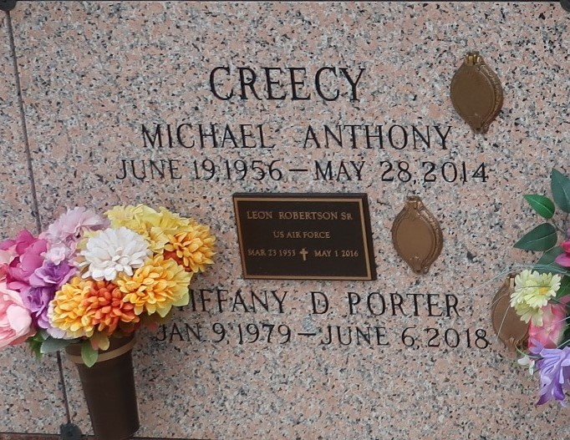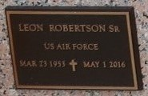

Sr. Pastor Leon Robertson, Sr., age 63, departed this life on Sunday, May 1, 2016. Son of the late Reverend Harry Robertson, Sr. and Elnora Robertson. Survived by two children, Leon Robertson, Jr. and Nikosha Robertson of Shreveport, LA; three grandchildren, two Goddaughters, Mrs. Tammy Gardner Lewis of Reserve, LA and Ms. DeNesia Anderson of Shreveport, LA; four sisters: Mrs. Theresa Gardner and Mrs. Beverly Creecy of Reserve, LA, Mrs. Brenda Collins of Atlanta, GA, Mrs. Evelyn Bazile of LaPlace, LA; four brothers: Mr. Calvin Robertson, Sr. of Reserve, LA, Mr. Edward (Wanda) Robertson, Sr. of Geismar, LA, Mr. Albert Robertson, Sr. of Baton Rouge., Mr. Clayton (Betty) Robertson of Gramercy, LA,, a host of nieces, nephews, other relatives and friends.
Employees of Chateau St. James Rehab and Retirement, 1980 Jefferson Hwy., Lutcher, LA, Shiloh Missionary Baptist Church, Mooringsport, LA. Funeral services will be held Saturday, May 7, 2016 at 12 Noon at Zion Travelers Missionary Baptist Church, 713 Walnut Street, LaPlace, LA 70068. Pastor Julius Ellis, officiating. Visitation 11:00 AM until service. Interment - St. John Memorial Park, LaPlace, LA Services entrusted to: Winnfield Funeral Home of Baton Rouge, 7221 Plank Road, Baton Rouge, LA 70811
The Times-Picayune, New Orleans, Louisiana
May 5 to May 6, 2016

